1.1 Simple Interest

Interest is money that is paid from one party to another for the privilege of having borrowed an initial sum of money called, the principal. At first, this definition of interest may seem to apply only to loans, but when you deposit money in a bank account, for instance, you have effectively loaned money to the bank, so the bank pays you interest rather than you paying the bank. For the sake of simplicity, we will adopt the vantage point that interest is being earned (as opposed to owed) on principal and we will distinguish between loans, accounts and investments only in the examples and as necessary.

There are many ways to compute interest, but the most basic one, on which many other types of interest are based, is simple interest. The idea behind simple interest is that the amount of interest earned on an account is directly proportional to the length of time that the principal was deposited. For instance, the amount of interest earned on a simple interest savings account after two years should be twice the interest earned after only one year. This suggests the following formula for calculating the total amount of simple interest earned:

(interest) = (amount of principal) × (interest rate) × (length of time)

Let us establish some notation so we can formalize this relation.

I = interest
P = principal
r = interest rate (in decimal form)
t = time (in years)

Then, in symbols, what we have said is that,

Simple Interest Formula

I = Prt

When working with the formula I = Prt, remember that r should be in decimal form.

Tip: Converting percents to decimal forms: To convert a percentage to decimal form, move the decimal point two places to the left. For instance, 9.2% → r = .092, while 13% → r = .13.
B

Also, all time intervals should be converted to years. For instance,

37 months → t = 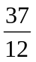 years (there are 12 months in a year)
19 weeks → t = 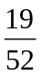 years (there are 52 weeks in a year)
281 days → t = 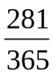 years (there are 365 days in a year)

Example 1: Joan borrows $1500 for 15 months at the simple interest rate of 12.0%. How much interest will she have to pay at the end of the 15 month period?

Solution: Since we wish to calculate the total amount of interest due on a simple interest loan, we use the formula I = Prt. The principal, P, is the amount borrowed, so we set P = 1500. The interest rate 12.0% is converted to r = 0.12 and the time, given in months, is converted to 15/12 years. Thus,

I = Prt
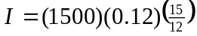
I = $225.00

Keystrokes: 1500 0.12 15 12 ENTER

Joan will have to pay $225.00 in interest. n

The primary use of the formula I = Prt is to compute the value of I by plugging in values for P, r and t. However, given any three of the four variables, we can always solve for the fourth. In the next example, the values of I, r and t are given and the value of P is sought.

Example 2:
In six months, Mr. Trapuzio earned $155.00 in interest on a CD (certificate of deposit) that paid 4.2% simple interest per year. What was the original value of the CD?

Solution: We will use the simple interest formula I = Prt. Note that we have been given the value of I = 155.00 and that we are looking for the value of P. Also, we know that r = 0.042 and t = 0.5 (half-a-year). Thus,

I = Prt
155.00 = P(0.042)(0.5)
To solve for P, we divide both sides of the equation by (0.042)(0.5),
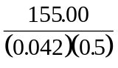= P
P = 7380.952381

Keystrokes: 155.00 ( 0.042 0.5 ) ENTER

We round P to the nearest penny to conclude that the value must have been $7380.95. n

A Note on Rounding: All final dollar amounts in this chapter will be rounded to the nearest penny. Unless otherwise stated, you should do the same on your answers to the homework problems. To do this, look at the digit in the third decimal place of the number you wish to round. If this digit is strictly smaller than 5, then truncate (chop off) the digits after the second decimal place. For instance, 2008.764321 would be rounded to 2008.76 (the digit 4 is smaller than 5). If the digit in the third decimal place is bigger than or equal to 5, then add one to the second decimal place and truncate the digits after the second decimal place. For instance, the number 41.836759 would be rounded to 41.84 (the digit 6 is bigger than 5).
B

Example 3: How much interest would you be paying on a five-year car loan of $11,200, if you paid off the loan in one lump sum of $14,280?

Solution: Any amount over the original $11,200 that is paid back must be interest. Thus, the interest is given by $14,280 − $11,200 = $3080. No formulas needed! n

Whenever we add interest I to a principal P, we get a larger amount which we will call the future amount and denote by the letter A. This means that we have the following relation,

A = P + I = future amount

In the previous example, the interest I = $3080 is added to the principal P = 11,200 to yield the future amount A = $14,280.

In financial calculations, the variable P is also called present value. You can think of the amount P as growing into the amount A over time by the addition of interest.

time
P = present value
A = P + I = future amount

By applying the formula I = Prt to the definition of A, we obtain another simple interest formula:

A = P + I [definition of A]
A = P + Prt [I = Prt]
A = P(1 + rt) [factor out the P]

The new formula is given below.

Simple interest formula II

A = P(1 + rt)

Tip: Which simple interest formula to use? Most of the time, either one will do but as a general rule of thumb, if you are given (or are looking) for the future amount A, use A = P( 1 + rt ), otherwise, use I = Prt. It will take a bit of practice to recognize whether or not the problem involves the future amount. Here are some examples to help.
B

Example 4: A $10,000 bond that pays 9.0% simple interest is cashed in after six years and three days. How much interest is earned on the bond?

Solution: Since we want only the interest I earned on the bond, we will use the simple interest formula I = Prt. We set P = $10,000 and r = 0.09. To set the variable t (time), we must convert six years and three days to years. Since six years is (6)(365) = 2190 days, we get 2190 + 3 = 2193 days. But we need t in years, so we divide by 365 days per year to get t = 2193/365.

I = Prt
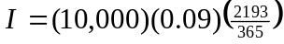
I = 5407.3973

Keystrokes: 10000 0.09 2193 365 ENTER

We round off to the nearest penny to conclude that the amount of interest earned is $5407.40.

Alternate Solution: In this example, we could also use the formula A = P( 1 + rt ) but the keystrokes are a little trickier, and there will be an additional step:

A = P(1 + rt)
A = 10,000( 1 + (0.09 2193 365) )
A = 15,407.39726

Keystrokes: 10000 ( 1 + ( 0.09 2193 365 ) ) ENTER

Now that we have A, the additional step is to subtract P from A (if A = P + I, then I = A − P):

I = A − P
I = 15,407.39726 − 10,000
I = 5,407.39726

As before, we conclude that the total interest is $5407.40. n

Here’s an example in which it’s better to use the formula A = P(1 + rt).

Example 5: How much money do you need to invest in an account paying 7.0% simple interest per year so that you will have a final balance of $45,000 in 26 months?

Solution: Since we want the future amount of the account to be $45,000, we will use the formula A = P(1 + rt) with A = 45,000 and solve for the principal, P. Note the conversion of time from 26 months to t = 26/12 years.

A = P(1 + rt)
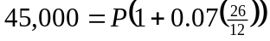
Keystrokes: 1 + 0.07 ( 26 12 ) ENTER

45,000 = P(1.1516666667)
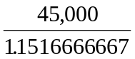= P
P = 39073.80608
So, you will need to deposit $39,073.81. n

Warning: Don’t truncate or round-off a number during a calculation - it could affect your final answer. For instance, one might be tempted in the above example to truncate 1.151666667 to 1.1516 when dividing it into 45,000. This would yield an answer that is off by about $2.26. Worse yet, if you were to round 1.1516666667 to 1.15, then this would yield an answer that is off by about $56.62. You might find it helpful to use the calculator memory to store intermediary results.


So far, we have answered questions of the form “how much” by solving for one of the variables I, P or A in one of our two formulas. We can also solve for the variables r or t , to answer questions of the form “how long” and “what interest rate is required”.

Example 6: What is the simple interest rate that is required on a bond so that in one year it will grow from $10,000 to $11,500?

Solution: We wish to solve for the variable r in the formula A = P(1 + rt) . We do this before plugging in any quantities:

A = P(1 + rt)
A = P + Prt [distribute P]
A − P = Prt [subtract P from both sides]
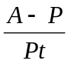 = r [divide both sides by Pt]
This may be thought of as a formula for r. Substituting A = 11,500, P = 10,000 and t = 1 year, we obtain
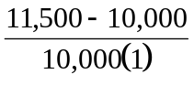 = r
r = 0.15

Keystrokes: 11500 − 10000 ENTER 10000 ENTER

Thus, you would need an interest rate of 15.00% on the bond. n

Example 7: How long must you loan out $3,000 in order to make $3,000 in interest? Assume that the simple interest rate is 9.5% per year.

Solution: We have been given the values P = 3000, I = 3000 and r = 0.095. We are looking for the value of t in the formula I = Prt:

I = Prt
3000 = 3000 (.095) t
Dividing both sides of the equation by the quantity 3000(0.095), we obtain:
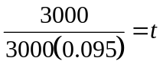
After canceling the 3000 in the numerator and denominator, we get,
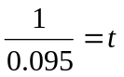
or,
t = 10.52631579.

So, you would need to loan the money for about 10.53 years. n

Problems

- How much interest will be earned on a $5000 bond that pays 6.0% simple interest per year, if it is allowed to mature for two-and-a-half years? Use either of the simple interest formulas, but if you use A = P(1+rt), remember to subtract P at the end.

- How much interest will be earned in 36 months on a simple interest account that pays 7.2% interest, if the initial deposit is $2000? Compute your answer with both of the simple interest formulas.

- How much will a $3000, simple interest bond be worth after six months if it pays 16.0% interest per year?

- Suppose that you have a simple interest loan of $5000 that charges 9.2% per year and that you pay it back with interest at the end of 24 months. How much will you have to pay?

- Ms. Briote purchased a municipal bond for $7000. After two and-a-half years, she cashed it in for $8330. How much interest did she make on the bond?

- Consider a $2000 bond that pays 8.1% simple interest per year. (a) How much interest will be made on the bond in one year? (b) Will exactly twice as much interest be made if the bond is held for two years? You should be able to answer this without calculating but go ahead and calculate to verify your response.

- Compute the amount owed (that’s interest plus principal) on a simple interest loan of $2100 if the interest rate is 11.5% and the money is borrowed for (a) one year (b) 36 months (c) five years.

- Carl borrowed $15,000 from Knuckles, the loan shark. He repaid $20,000 eight weeks later. (a) How much interest did he pay to the loan shark? (b) What simple interest rate does this correspond to?

- Calculate the amount in an account that had an initial balance of $3000 and paid 7.0% simple interest per year if the account were held open for (a) 13 months (b) 27 weeks (c) 281 days.

- If a simple interest loan is held for three years instead of one year before paying it back, will three times as much interest be owed? Why or why not?

- How long should a $5000 simple interest bond be matured in order to make $250 in interest? Assume that the bond pays 9.2% interest.

- What interest rate would be required on a simple interest account so that, in two years, $6000 would grow to $7000?

- Suppose that at the end of 52 months, the balance on a simple interest account were $10,000. If the account pays 5.5% interest per year, what was the balance at the beginning of the 52-month period?

- How much money would you need to deposit into an account that pays 9.0% simple interest per year so that you would have exactly $5000 at the end of 72 weeks?

- If a person made $500 interest in one year on a simple interest bond that paid 10.0% per year, what was the original purchase price of the bond?

- Find the amount of principal borrowed in the following scenario: $15,500 was repaid (interest plus principal) after 16 months on a loan that charged 6.5% simple interest per year.

Web

- Simple Interest CD's. Search the web to find two different 6-month simple interest CD (certificate of deposit) offers with different interest rates. Use search-words such as "simple", "interest", "rate", "CD" and "month". Be careful not to use rates that are labeled APY (annual percentage yield), we will learn about these rates in a later section. (a) Compare how much interest you would make on each of the two offers you have found assuming a $5000 CD. (b) Compare how much interest you would make on each of the two offers assuming a $50,000 CD.
Solutions

Accuracy: Your answers may vary from the ones here due to different rounding techniques and calculator performance. You should be concerned only if your answer is off by more than a penny or two.

- $750.00 interest is earned on the bond.

- $432.00 interest is earned. (The amount in the account will be $2432.00.)

- The bond will be worth will be worth $3240.00.

- You’ll pay $5000.00 in principal and $920.00 in interest, for a total of $5920.00.

- She made $1330.00 in interest.

- (a) $162 in interest in one year. (b) Yes, the amount of interest is directly proportional to the length of time.

- (a) $2,341.50 (b) $2,824.50 (c) $3,307.50

- (a) Carl paid $5000.00 in interest. (b) That’s over 216% interest per year!!

- (a) $3,227.50 (b) $3,109.04 (c) $3,161.67

- Yes, three times as much interest will be owed because simple interest is directly proportional to the length of time, t. That is, I = Prt.

- It should be matured for the length of time t = 0.5435 years, which is about 199 days.

- The required interest rate is 8.33% (r = 0.083333).

- It must have been that P = $8075.3701.

- You would need to deposit P = $4445.96.

- The original purchase price was $5000.

- The amount borrowed was P = $14,263.80.

1.2 Compound Interest

The idea behind compound interest is to earn interest not only on the principal but also on whatever interest has been accumulated. For instance, suppose that you have invested $1000 in a simple interest account that pays 10.0% per year and that the bank has agreed to compound twice per year. This means that at the end of each half-year, the bank will deposit into the account any interest earned. The (simple) interest accumulated after half-a-year would be

I = Prt = 1000.00(.10)(1/2) = 50.00

and the total balance on the account would be the original $1000 plus the $50 interest:

Mid-year balance = $1000.00 + $50.00 = $1050.00

At the end of the year, the amount of interest you have earned for the last half of the year would be computed on this higher balance, $1050:

I = Prt = 1050.00(.10)(1/2) = 52.50 .

The final balance on the account is given by:

End-year balance = $1050.00 + $52.50 = $1102.50 .

Note that the total interest earned on the account via this compounding process is $102.50. If the account had paid straightforward simple interest, the total interest earned would have been 10% of $1000, or, $100. The compounding yielded extra interest of $2.50. The extra $2.50 came from the interest earned on the $50.00 interest that sat in the account for the second half of the year. This extra interest is not a lot of money but is proportional to the starting balance. If the starting balance were 100 times greater (i.e., $100,000) then the interest would be 100 times greater, that is, $250.

Moreover, as money is compounded over a long period of time, the benefits of compounding become quite noticeable because interest builds on interest. This snow-balling effect is accentuated by more frequent compounding.

The compounding process is really a series of simple interest (I = Prt) calculations done back to back. That is, at the end of each compounding period, one computes the amount of interest I =Prt earned on the balance P for that period, then adds I to the prior balance to yield a higher balance, which becomes the value of P when calculating I = Prt in the next compounding period. The results of these simple interest calculations can be organized into a table so that you can compute the balance on the account at various points in time.

Constructing a Compound Interest Table
Suppose we have an account with an initial balance of $5000 that pays 13% interest, compounded annually and that we wish to know the balance after 3 years. We start the compound table by establishing the following rows and columns and entering the starting balance, as below.

Year | Balance Start | Interest | Balance End
1 | 5000.00
2
3

Next, we compute the interest for the first year via the simple interest formula, I = Prt. We obtain

I = Prt = 5000(.13)(1) = $650.00

and enter it into the table:

Year | Balance Start | Interest | Balance End
1 | 5000.00 | 650.00
2
3

The balance for the end of the year is the starting balance, $5000.00, plus the $650.00 interest earned, or 5000.00 + 650.00 = 5650.00. We enter this amount into the table as the ending balance for year 1 and as the starting balance for year 2.

Year | Balance Start | Interest | Balance End
1 | 5000.00 | 650.00 | 5650.00
2 | 5650.00
3

The calculation for the second year’s interest is similar, namely,

I =Prt = (5650.00)(.13)(1) = 734.50

and the new balance is 5650.00 + 734.50 = 6384.50:

Year | Balance Start | Interest | Balance End
1 | 5000.00 | 650.00 | 5650.00
2 | 5650.00 | 734.50 | 6384.50
3

Finally, the calculation for the third year’s interest is given by:

I =Prt = (6384.50)(.13)(1) = 829.99

and the new balance is 6384.50 + 829.99 = 7214.49:

Year | Balance Start | Interest | Balance End
1 | 5000.00 | 650.00 | 5650.00
2 | 5650.00 | 734.50 | 6384.50
3 | 6384.50 | 829.99 | 7214.49

So, the balance at the end of 3 years is $7214.49.

If we want to compute the balance after, say, ten years, then we could continue the above manual process seven more times. This would be tedious, indeed. With the help of the spreadsheet tutorial in the Spreadsheet Appendix, you will be able to automate the process of constructing such a table. This is exactly what we did to produce the next table, which shows the interest and balance for each of ten years. In particular, we copied the cell relations of row three into each of the next seven rows.

Year | Balance Start | Interest | Balance End
1 | 5000.00 | 650.00 | 5650.00
2 | 5650.00 | 734.50 | 6384.50
3 | 6384.50 | 829.99 | 7214.49
4 | 7214.49 | 937.88 | 8152.37
5 | 8152.37 | 1059.81 | 9212.18
6 | 9212.18 | 1197.58 | 10409.76
7 | 10409.76 | 1353.27 | 11763.03
8 | 11763.03 | 1529.19 | 13292.22
9 | 13292.22 | 1727.99 | 15020.21
10 | 15020.21 | 1952.63 | 16972.84
Compound Interest

The bottom row shows that the balance at the end of 10 years would be $16,972.84. We emphasize the fact that each year’s balance was obtained by performing a simple interest calculation involving the previous year’s balance. Moreover, while it is useful to have the interest column displayed, we did not need to include it. Each ending balance can be computed by applying the simple interest formula A = P(1 + rt), with P equal to the ending balance from the previous year.

Compound Versus Simple Interest: The Snowballing Effect
In order to contrast the growth rates of compound interest and simple interest, let us assume that there are two accounts, each with a starting balance of $5000: one that pays 13% simple interest, and one that pays 13% interest, compounded annually. The table below shows the interest earned and final balance for each of the two accounts (we augmented the previous table with columns for the simple interest account).

 |  | Compound  Account |  | Simple  Account
Year | Balance Start | Interest | Balance End | Interest | Balance End
1 | 5000.00 | 650.00 | 5650.00 | 650.00 | 5650.00
2 | 5650.00 | 734.50 | 6384.50 | 650.00 | 6300.00
3 | 6384.50 | 829.99 | 7214.49 | 650.00 | 6950.00
4 | 7214.49 | 937.88 | 8152.37 | 650.00 | 7600.00
5 | 8152.37 | 1059.81 | 9212.18 | 650.00 | 8250.00
6 | 9212.18 | 1197.58 | 10409.76 | 650.00 | 8900.00
7 | 10409.76 | 1353.27 | 11763.03 | 650.00 | 9550.00
8 | 11763.03 | 1529.19 | 13292.22 | 650.00 | 10200.00
9 | 13292.22 | 1727.99 | 15020.21 | 650.00 | 10850.00
10 | 15020.21 | 1952.63 | 16972.84 | 650.00 | 11500.00

The final row of the table shows that, after 10 years, the amount in the compound account is $16,972.84, while the amount in the simple interest account is only $11,500.00. Why the big difference? The compound interest account earned interest on interest, causing the yearly interest amount to increase. However, the amount of interest earned on the simple interest account remained constant at $650.00 each year (scan down the two interest columns).

Below, we have graphed the yearly balances for each of the two accounts over a 30-year period. Note that both balances increase over time but the balance on the compound account grows much faster. The balance on the simple interest account grows linearly (it follows a straight line) while the balance on the compound interest account grows super-linearly (curved upward).

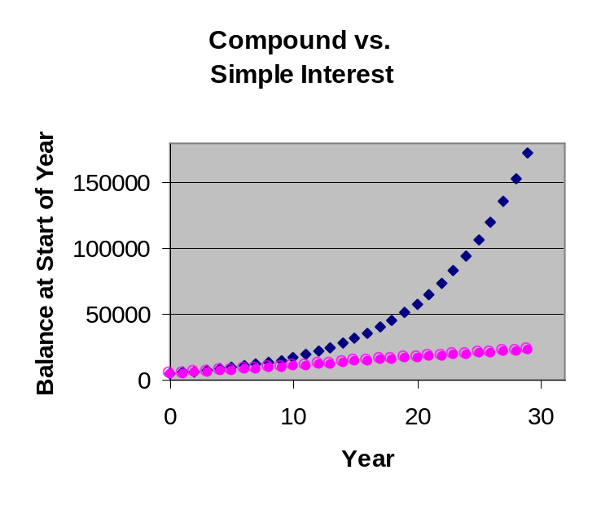
Compound
Simple

In the short run (a few years) the interest earned on the accounts are comparable. But, in the long run, the difference between the two balances is quite dramatic. After 20 years, the interest in the compounded account is over four times that of the simple interest account. After 30 years, the interest is over seven times that of the simple interest account!

The Compound Interest Formula
Next, we introduce a compound interest formula that computes the final balance at some future date, without having to make all the interim calculations.

Let n = the compounding frequency, meaning, the number of times per year that a quantity is compounded. For instance, if P is compounded monthly, then n = 12 (twelve times per year) and if P is compounded quarterly, then n = 4 (four times per year). The compound interest formula is given below.

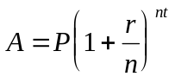

We will adopt the following short-hand notation:

i = r/n N = nt.

This is not merely a convenience. The quantities have meaningful interpretations. The value i is a periodic interest rate and the value N is the total number of times the money was compounded. Substituting this notation into the above version of the compound interest formula, the future amount, A, after N compounding periods is given by the following expression.

Compound Interest Formula
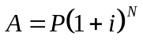

where,

A = future amount
P = principal
i = r/n
N = nt = total number of compounding periods
r = interest rate
n = number of compoundings per year
t = time (in years)

Warning: The quantity n is the number of compoundings that would take place if the account existed for exactly one year. This is different from the quantity N, which is the total number of compoundings that actually take place. For instance, if an account is compounded monthly over one year, then n = 12 and N = 12. However, if the account is terminated after only half-a-year, then we still have that n =12, but N = 6, because only six compoundings actually take place. (Also, you can formally compute N = nt = 12(1/2) = 6.)

Example 1:
(a) How much money would be in an account at the end of five-and-a-half years if the initial deposit were $14,000.00 and the account paid 9.0% interest, compounded weekly?
(b) How much total interest would be earned on the account?
(c) How much interest would be earned in the first year?

Solution: (a) We are looking for the future amount A in the compound interest formula. So, we make the following substitutions:

P = 14,000
N = nt = (52)(5.5) = 286
i = r/n = (0.09)/(52)

We have set n = 52 because weekly compounding is done 52 times per year. Also, note that we computed N, the total number of compounding periods, in advance in order to facilitate the keystrokes when we enter it as an exponent. However, we have left the quantity i as a fraction because it is liable to have a messy decimal expansion that is hard to retype. Substituting into the compound interest formula,

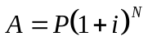 ⇒ 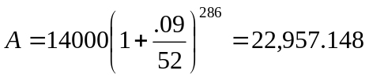

Keystrokes: 14000 ( 1 + .09 52 ) ∧ 286 ENTER

Note: The exponent key on your calculator might be or instead of .
y^{x}
x^{y}
^
So, there would be $22,957.15 in the account at the end of 5.5 years.

(b) To calculate the total interest, we do not need any formulas. The principal $14,000.00 grew to $22,957.15, so, the difference between these two numbers must be the total interest earned on the account. That is, total interest = $22,957.15 − $14,000.00 = $8957.15.

(c) To calculate the interest earned in the first year, we repeat our original calculation (using the compound interest formula) with t = 1.0 instead of t = 5.5. This time, we find that the amount A is $15,317.25. Here, A is the amount in the account after one year. So, the interest earned after one year would be $15,317.25 − $14,000.00 = $1,317.25. n

Example 2: Suppose that a particular type of bond pays 8.0% interest per year, compounded daily, and that the bond can be purchased in any denomination. How much should the bond be purchased for so that it is worth $12,000 when it is cashed in after five years? How much interest will be earned on the bond?

Solution: We have been given the value A = $12,000 in the compound interest formula and we are looking for the value of P. We will set r = 0.08, n = 365 (compounding daily) and t = 5 so that i= .08/365 and N = 365(5) = 1825. But before we substitute these numbers, we solve for P algebraically in the compound interest formula by dividing both sides of the equation by the quantity, 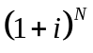, as follows.

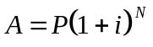 ⇒ 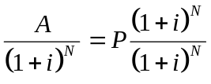 ⇒ 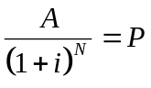 ⇒ 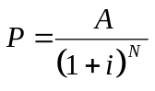
After substitution, we obtain,

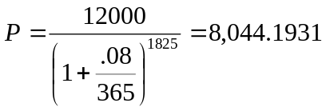

Keystrokes: 12000 ( 1 + .08 365 ) 1825 ENTER

You would need to purchase the bond for about $8,044.19. The total amount of interest earned on the bond would be the difference between what it was cashed in for and the purchase price:

Total interest = $12,000.00 − $8,044.19 = $3,955.81. n

The next example shows that it is often necessary to "stop the clock" and make back-to-back calculations on an account in order to calculate the effects of a change in the terms (such as the interest rate or frequency of compounding) imposed on the account.

Example 3: Suppose that you deposit $10,000 into an account that pays 7.0% interest, compounded quarterly but that, midway through the year, the bank starts compounding the account monthly at the rate of 9.0%. How much will be in the account at the end of the year?

Solution: This problem will require two calculations. First, we will calculate the amount of money in the account at the mid-year point. We are looking for A in the compound interest formula using the following substitutions.

P = 10,000.00 A = ?
r = 0.07 i =.07/4
n = 4 N = nt = 4(.5) = 2.
t = 0.5 [half a year]

Substituting into the compound interest formula,

⇒ 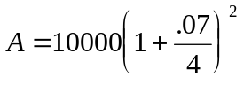.

Keystrokes: 10000 ( 1 + .07 4 ) ∧ 2 ENTER

Mid-year balance: A = 10,353.06.

Next, we start with the above balance (the A above becomes P in the next calculation) and project it forward in the compound interest formula to see what the balance will be at the end of the year. Again, we set t = 0.5 (representing the second half of the year) but the bank has changed the interest rate to r = 0.09 and the compounding frequency to n = 12. Thus, N = 12(.5) = 6 and we obtain

⇒ 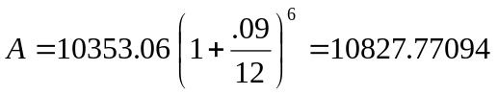

Keystrokes: 10353.06 ( 1 + .09 12 ) ∧ 6 ENTER

So, at the end of the year, there will be about $10,827.77 in the account. n

Warning: A common mistake in the foregoing example is to add the two balances $10,353.06 and $10,827.77. That would be like saying that if you weighed 100 pounds on your tenth birthday and weighed 150 pounds on your twentieth birthday, then you must weigh 250 pounds!

Where Does the Compound Interest Formula Come From?
Consider $10,000 in an account that compounds monthly at 7.0%. At the end of the first month, the balance can be computed using the simple interest formula, A = P(1+rt), with P = 10,000, r = .07, t = 1/12. The balance at end of the first month is

10,000(1 + .07/12).

(It will be instructive to leave this expression as is.)

At the end of the second month, the balance can be computed using the simple interest formula, A = P(1+rt), with P = 10,000(1 + .07/12), r = .07, t = 1/12. The balance at end of the second month is

10,000(1 + .07/12) (1 + .07/12).

Similarly, at the end of the third month, the balance can be computed using the simple interest formula, A = P(1+rt), with P = 10,000(1 + .07/12)(1 + .07/12), r = .07, t = 1/12. The balance at end of the third month is

10,000(1 + .07/12) (1 + .07/12) (1 + .07/12).

Using exponential notation, this can be written as 10,000(1 + .07/12)³.

In general, after N months, the balance is

10,000(1 + .07/12)^{N}.

But the starting balance, $10,000 could have been any amount, which we will call P; the interest rate, 0.07, could have been any interest rate r; the number of compoundings per year could have been any integer, n. Thus, the balance after N compounding periods (the future amount) is given by the following expression, which is the compound interest formula.

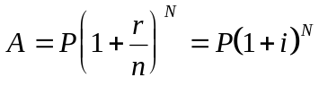

Continuous Compounding
For a fixed interest rate in a savings situation, quarterly compounding is better than annual compounding, monthly compounding is better than quarterly compounding, and so on. But one must wonder if the benefit of compounding more often steadily grows or tapers off. Below, we have calculated the one year balance of an account whose principal is $10,000 at 6.0% interest compounded annually, quarterly, monthly, weekly, daily, and every hour.

annually | 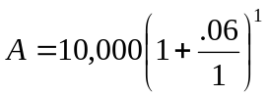 | =$10,600.00
quarterly | 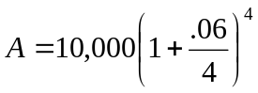 | =$10,613.64
monthly | 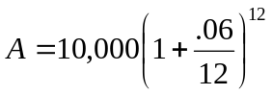 | =$10,616.78
weekly | 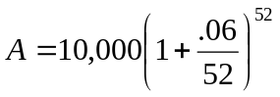 | =$10,618.00
daily | 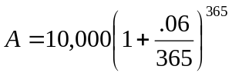 | =$10,618.31
hourly | 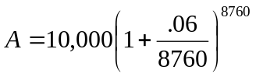 | =$10,618.36
each minute | 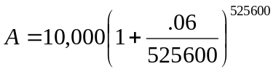 | =$10,618.37
each second | 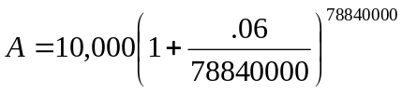 | =$10,618.37

As you can see from the table, the effect of compounding tapers off as the number of compoundings per year gets large. In fact, if the above account were compounded continuously (every instant, so to speak), then the balance after one year would be $10,618.37! The formula to compute continuously compounded interest is given below.

Continuously Compounded Interest Formula
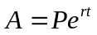

A = future amount P = principal
r = interest rate t = time (in years)
e ≈ 2.718281828

So, if our $10,000 account were compounded continuously, the balance after one year would be:

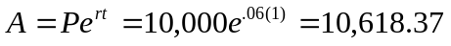

Keystrokes:
10000 × e^{x} (.06 × 1) ENTER

(Note: For older scientific calculators, e^{x} is keyed in by pressing INV followed by LN).

Problems

- Find the balance on an account at the end of 26 months if the account pays 7.5% interest
per year, compounded monthly, and the initial balance is $3000.

- What initial balance would be required on an account that pays 10.0% interest per year, compounded monthly, so that one has $10,000 in the account after 2.5 years?

- Ms. Trugglan purchased a bond for $5000 at the start of 1986. The bond paid 12.0% interest, compounded weekly. How much interest did she make when she cashed in the bond at the start of 1992?

- How much money should you invest in an account that pays 9.0% interest, compounded daily, so that you have $20,000 after six years?

- Determine which of the following two investments will make more interest on $10,000: an investment that pays 10.0% interest compounded twice per year or one that pays 9.5% interest per year compounded daily. [Hint: Any time period will do; try using one year.]

- Suppose that your first child, Binky, was just born and that you wish to save for his college education by purchasing a bond that pays 7.0%, compounded daily. You estimate that Binky’s education will cost $56,000. How much should the bond be purchased for? (Note: you’ll have to estimate how old Binky will be when he starts college.)

- Approximately how long would you need to hold a T-bill so that it is worth double its original value of $10,000? The T-bill pays 6.1% interest per year, compounded daily. [Hint: Try different values of t. Start with t = 15, then increase or decrease t as needed.]

- Suppose that you deposit $5000 into a savings account that yields 5.0% interest, compounded quarterly, and that after two years, the terms on the account are changed to 6.1% interest per year, compounded daily. (a) How much money will be in the account after a total of six years? (b) How much total interest will you make?
7
- You borrow $2000 from your Uncle Harry and he charges you 7.0% interest per year, compounded monthly (some Uncle, huh?). If you pay him the principle and interest in full after 72 weeks, (a) how much money will you owe him? (b) how much interest will he make off of the loan?

- Suppose that your retirement fund pays 10.0% interest per year, compounded monthly, and that you deposit $50 into the fund in January of 1995. How much interest will you make off of the $50 after 40 years?

- Consider the retirement fund from problem 10. How much should you deposit into the account now so that it will grow into $100,000 in 40 years? Assume that you make no other deposits or withdrawals from the account.

- Samantha purchases a dishwasher from Sears for $350 and charges it to her Citibank Visa card. Citibank charges her 15.6% interest, compounded monthly, on all purchases. If she leaves this $350 outstanding on her card for two years, how much interest will she pay?

- Ricky has a balance of $3200 on his Mastercard (credit card), then he transfers $2100 to the same card from his Visa card. Mastercard charges him 16.2% interest per year, compounded monthly, on the $3200 balance and 19.0% interest per year, compounded monthly, on the transfer balance. How much total interest will Ricky pay on his Mastercard after one month? [Hint: Treat the two balances as two separate accounts - that’s what the credit card companies do].

- Suppose that you have a balance of $2000 on your credit card and that you make monthly payments of $50 at the end of each month. Your credit card company charges you 17.0% interest, compounded monthly. What will your account balance be at the end of three months? [Hint: make three calculations, one at the end of each month.]

- Estimate to within two decimal places the annual interest rate compounded monthly that would be required from your bank so that you could hold $3000 of their money for one year (making no payments) and keep the total interest under $250. (Hint: Try different values of r in the compound interest formula).

- Suppose that you have an account yielding 6.9% interest, compounded quarterly. Will the interest earned on the account after three years be (exactly) three times the interest earned after one year? Why or why not? Hint: Try compounding an initial balance of $1000. (b) What if the account pays simple interest at 6.9% per year?

- In the interest of being more competitive, your credit card company has just dropped your interest rate from 15.6% to 9.9%, compounded monthly. If your average balance is $3000, how much savings will this be for you over the course of one year?

- Patsy wishes to live off of the interest earned from her bank account, which has a current balance of $500,000. She will withdraw only the interest at the end of each month so that the balance at the start of each month remains at $500,000. Assuming that the bank pays 6.5% interest per year compounded monthly, how much will she withdraw each month?

- Complete the following table which shows the monthly breakdown of a $5000.00 loan taken out at 9% interest, compounded monthly. This is a deferred payment loan, meaning that it is repaid in one lump sum (principal and interest) at the end of six months.

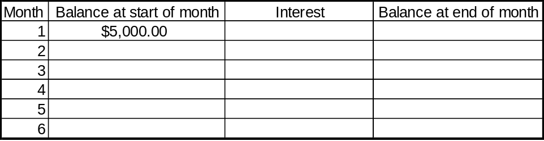

- Complete a table (as in the previous problem) that shows the yearly breakdown of a $10,000 savings bond over 10 years. Assume that the bond that pays 10% interest, compounded annually.

- Use a spreadsheet to solve the following problem: In January of 1990, Valerie invested $2500.00 in a savings account that paid 4.4% interest, compounded annually. In January of 1994, the bank lowered the interest rate to 4.0% (still compounded annually) and lowered it again in January of 1995 to 3.4%. What was the balance in her account at the end of 1997? How much interest did she make over the eight-year period?
7

- A $10 ,000-savings bond pays 5.5% interest compounded annually. Use a spreadsheet to create a table that displays the following account information each year over a 35-year period: starting and ending balances, interest for the year (for help, see the spreadsheet tutorial in the appendix). (b) How long will it take for the balance to exceed $45,000? (c) How much total interest is earned in the first 10 years? (d) How much total interest is earned in the first 20 years? Is this twice the interest earned in 10 years? Why not?
7

- Compute the future amount of a 5-year, $25,000 certificate of deposit that pays 5.5% APR, compounded continuously.

- How much should Jane deposit into an account that pays 4.4% interest compounded continuously, so that she will have $51,200 ten years from now?

Thinkers

- Compound interest formula vs. Spreadsheet. The compound interest formula does not always give the same answer that one would get by using a spreadsheet with periodic breakdowns. To see this, consider an account with starting principal $632.87 and interest rate 7.5%, compounded quarterly. Create a spreadsheet that displays the following account information each quarter for a 10-year period: starting and ending balances, interest for the quarter. Round your interest calculations to the nearest penny by entering the Excel function: =ROUND( , 2) into each cell where you normally calculate quarterly interest [put the usual formula that calculates interest inside the blank]. (a) Compare the ending 40th quarter balance given by the compound interest formula with that given by the spreadsheet. (b) In a few sentences, explain which answer gives the actual balance of the account after 40 quarters.
7
7

- Rule of 72. The rule of 72 states that, in order to estimate how many years it will take to double an investment by compounding, divide 72 by the annual interest rate (left in percentage form). For instance, if the annual interest rate were 10%, then it would take about 72/10 = 7.2 years to double your investment. This rule is good for estimates or when no calculating devise is readily available. But how accurate is this rule? In order to answer this, construct a spreadsheet that computes the amount of time required to double an investment two different ways: by the rule of 72, and by the exact formula that follows: Doubling time = LN(2) / (LN ( 1 + r / n ) * n) Note: In place of r and n, you would write the cells that contains these values. To make things simpler, enter 12 for the value of n (monthly compounding). Use the spreadsheet to compare the accuracy of the rule of 72 against the exact formula for the interest rates 1%, 2%, …, 30%. What do you conclude? How did the accuracy vary with the interest rate? Note that the rule of 72 does not take into account the frequency of compounding (the variable n). Check whether or not the accuracy of the rule varies with n. Do this by repeating part (a) for different values of n. For instance, try n = 1, 4, 12, 365 (for yearly, quarterly, monthly and daily compounding).

Web

- Search the web to find five different offers for a 1-year CD: one compounded annually, one quarterly, one monthly, one daily, and one continuously. Which would you prefer to invest $45,000 for one year? Be careful not to use rates that are labeled by APY (annual percentage yield), we will learn about these rates in the next section.

- Suppose that you have a $6,000 balance on a Visa card with an APR of 21% APR. Over the next six months, you will be able to pay only $100 per month towards this debt. Search the web to find a credit card offer with the lowest rate you can find on balance transfers. Give the web address of the credit card offer and compute the amount of money you will save in interest over the next 6 months, if you transfer the balance to this credit card. [Hint: You will need to break up the problem into 6 simple interest calculations.]

Solutions

- The balance would be A = $3527.56.

- The required initial balance would be P = $7796.08.

- She made $5263.65 in interest.

- You should invest $11,655.75.

- The first investment makes more interest. For instance, after one year, it will yield a total of $11,025 while the second investment will yield $10,996.45.

- College in 18 years: $15,886.56
College in 19 years: $14,812.63
College in 20 years: $13,811.30

- A little less than 12 years.

- There will be $5522.43 after 2 years. Compounding this amount for the remaining four years yields (a) $7048.38 after six total years. (b) Interest = $2048.38

- (a) You will owe a total of $2202.93. (b) You will owe $202.93 in interest.

- $2635.03 (Did you remember to subtract the $50 ?)

- You will need $1862.18.

- Samantha will pay $127.19 in interest. (Remember to subtract the principal P = 350.)

- The total interest is $76.45. This is the sum of the $43.20 interest on the $3200 and $33.25 interest on the $2100.

- Balance after 3 months: $1934.07. How to obtain the answer:

End of month 1: Owe: 2028.33 (previous balance plus interest)
Pay: 50.00
Bal: 1978.33

End of month 2: Owe: 2006.36 (previous balance plus interest)
Pay: 50.00
Bal: 1956.36

End of month 3: Owe: 1984.08 (previous balance plus interest)
Pay: 50.00
Bal: 1934.07

- The required interest rate is 8.03%.

- (a) No. For instance, after one year, an initial balance of $1000 earns $70.81 in interest while after three years, it earns $227.81 in interest, which is more than three times $70.81. (b) Yes. In contrast to compound interest, simple interest earned is directly proportional to the length of time. One can see this in the simple interest I = Prt or by computing an example.

- You will save $192.11 over the course of one year. Note: for one year the interest at 15.6% will be $502.96, while the interest at 9.9% will be $310.85 for a difference of $192.11

- She will withdraw $2708.33 dollars each month.

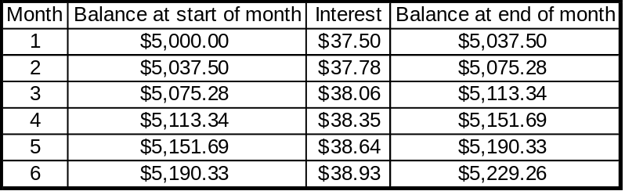

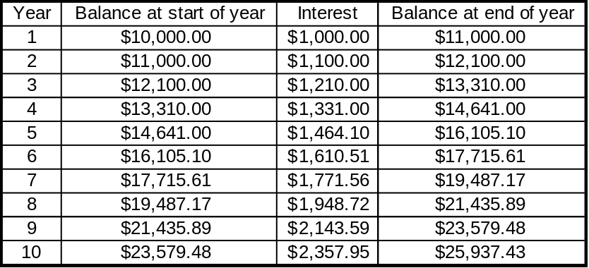

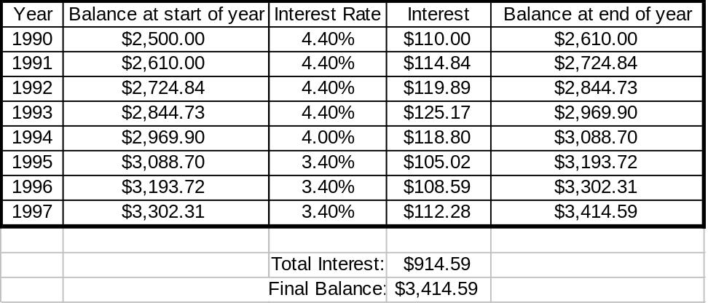

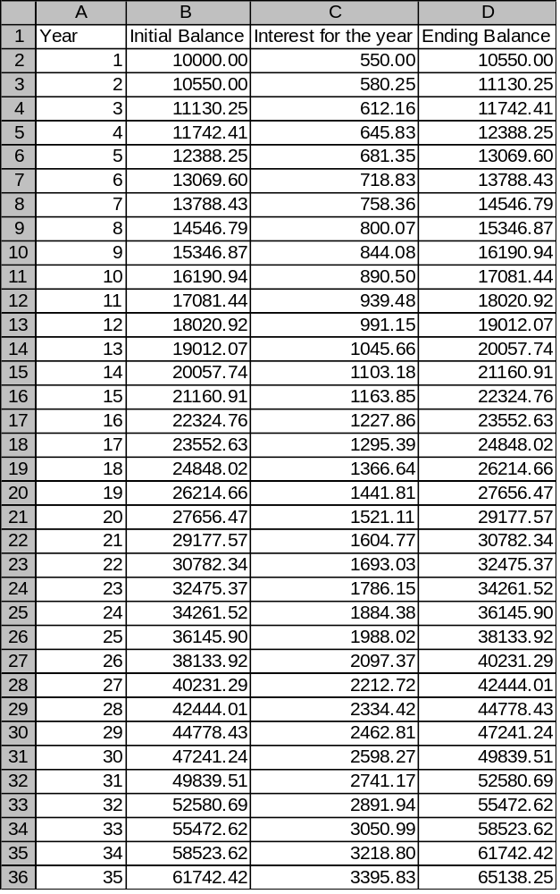

(a) It will take 29 years to exceed a balance of $45,000.
(b) After 10 years, the total interest earned will be $7081.44.
- After 20 years, the total interest earned will be $19,177.57. The interest earned after
20 years is more than twice the interest earned after 10 years. This is the effect of
compounding.

23. After five years, the future amount is $32,913.27.

24. Jane needs to deposit $32,974.67.

1.3 Annual Effective Rate (AER)

Annual effective rate (AER) is the percentage by which money grows in an account (or on a loan) in one year. That is,

AER = 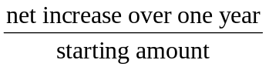

When an account that pays 10% interest per year is compounded more than once per year, then the actual annual increase in the account will be a little more than 10%, depending on how often the account is compounded. For instance, if the account is compounded monthly, then the increase over one year will be 10.47%, while a daily compounding will yield 10.52%. In this section, you will learn how to compute these annual effective rates.

Banks often provide the AER for an account (or bond) along with the nominal (quoted) interest rate for consumers to use as a guideline. The AER tells the consumer the percentage by which their money will grow in the account over a year’s time without having to actually compute it. The next time you visit a bank, look for the words “annual effective rate (AER)” or “annual percentage yield (APY)” on any of their postings.

Example 1: Suppose that, over the course of one year, an initial balance of $5200 increased to $6,000. What is the annual effective rate on this account? (Assume that no additional deposits or withdrawals were made in the account.)

Solution: Annual effective rate is the percentage by which money grows in the account in one year. That is,

AER = = 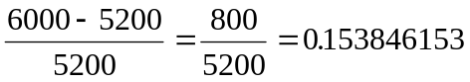.

Thus, there was an increase of about 15.38% over one year. The AER on the account is
approximately 15.38%. n
Example 2 : What is the AER on an account that pays 7.0% interest per year, compounded daily?

Solution: The quoted (nominal) annual percentage rate (APR) in the account is 7.0% but we expect the annual effective rate (AER) to be a little higher, due to compounding. In order to compute In order to compute AER, we return to the definition:

AER = .

Although we have not been supplied with the quantities in the above ratio, we can generate them by supposing a starting amount and compounding it in the account over one year. The difference between the ending amount and the starting amount will be the net increase over one year. We choose to use $100 as our starting amount (any other positive amount would do but $100 is easy to work with). We have the following substitutions in the compound interest formula:

P = 100 A = ?
r = 0.07 i = .07/365
n = 365 N = nt = 365(1) = 365
t = 1

⇒ 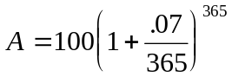

Keystrokes:
100 × ( 1 + .07 365 ) 365 ENTER

We obtain A = 107.2500983 [don’t round this number yet]. Since the starting amount was $100, the percentage increase is

AER == 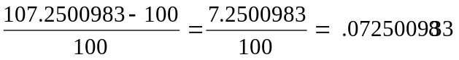

The AER on the account is about 7.25%. n

In Example 2, $100 was a particularly convenient starting amount to choose. In fact, note that the final AER, 7.25%, could have been “read off” the future amount, A = 107.2500983.
B

Example 3 : Suppose that you deposit $1700 into an account with an AER of 9.3807% that pays 9.0%, compounded monthly. How much interest will you earn in one year?

Solution: There are two ways to approach this problem. One is to ignore the AER and use the compound interest formula to compute the balance after one year (using P = $1700), then subtract the starting balance to obtain the interest. A shorter way is to recall that AER is the percentage by which the starting balance will increase in one year. So, all we need to do is multiply the starting balance by .093807 (this gives the interest after one year):

(.093807)(1700) = 159.4719

The account will earn about $159.47 in interest. n

For convenience, we have adopted the convention of reporting AER’s to two decimal places of accuracy. But if an AER is to be used for any subsequent calculations, it should not be rounded (see problem #17). In fact, most banks would report an AER with far more than two decimal places.
Problems

- What is the definition of annual effective rate?

- Consider an account that pays 8.2% interest, compounded monthly. (a) Compute the AER on this account (as in Example 2) using the following initial balances: $100, $500 and $1297. (b) Did your answer vary with the starting amount? What do you conclude from this?

- What is the annual effective rate (AER) on an account that pays 7.0% interest per year,
compounded daily?

- Suppose that you made a $10,000 investment that yielded $1200 interest over the course of one year. What is the annual effective rate on this investment?

- What is the annual effective rate on a bond that yields 12.0% interest per year, compounded weekly?

- A certain bank account balance is $17,300 at the end of the year. If the balance at the
beginning of the year was $15,000, then what is the AER on the account?

- Compute the annual effective rate on an account that pays 10.2% interest per year, compounded monthly.

- Suppose that in one year’s time, an account balance grew from $1200 to $1350. By what percent did the account grow? How is this related to AER?

- Calculate the annual effective rate on a loan that charges 9.3% interest per year, compounded daily. Assume that the loan is paid back in one lump sum at the end of the year.

- An account that quotes 10.0% interest per year, compounded daily, will yield slightly more than 10.0% interest per year due to the frequent compounding. What will be the actual percentage increase on the principal after one year?

- If you have a bond that pays 11.0% interest per year, compounded monthly, then the bond will grow each year at a rate slightly higher than 11.0%. Compute the higher rate.

- If a bond pays 12.0% interest per year, compounded daily, will the bond’s value increase by exactly 12.0% after one year? Why or why not?

- If a bond pays 12.0% interest per year, compounded annually, will the bond grow at the
rate of 12.0% per year? Why or why not? Compute the AER if you’re not sure.

- Compute the AER on account paying 8.95%, compounded daily, then on an account paying 9.0%, compounded quarterly. (a) Which account has a higher AER? (b) Will the AER on the 9.0% account increase if it is compounded more often? (c) Can the 9.0% account be compounded often enough to have a higher AER than the 8.95% account compounded daily?

- Consider an account that pays 10.0% interest per year. Calculate the AER for the account if it is compounded (a) once per year (b) twice per year (c) quarterly (d) monthly (e) daily (f) 10 times per day. [Round off to two decimal places, e.g., 10.12%]. Based on the above answers, do you think the account could be compounded often enough to achieve an AER of 11.0%?

- Suppose that the annual effective rate for a given account is (exactly) 8.2% and that you invest $12,000 in the account. How much money will be in the account at the end of the year?

- Rounding AER: Be aware that if a rounded AER is used to compute a balance, then the accuracy of the final answer might suffer. To see this, suppose that an account has an AER of exactly 15.3846153% and that three students have rounded this number to 15%, 15.38% and 15.38462%, respectively. In each of these three cases, use the (rounded) AER to compute the interest earned on $100,000 over one year. Then, see how far off it is from the exact amount of interest earned ($15,384.62).

Web

- Search the web for current interest rates for 6-month simple interest CD's. Find a bank that also posts the APY (annual effective rate) along with the stated simple interest rate. In a sentence or two, explain why this simple interest account has an AER that is different than the posted rate. (Hint: recall the definition of AER). (b) Verify the AER of this account with a calculation.
Solutions

- The percentage by which the principal grows in one year.

- (a) After rounding the percentage to two decimal places, you should get 8.52% in each of the three cases. (b) From part (a), we infer that you can use any starting amount to compute an AER. (This can be proven algebraically).

- The AER is 7.25%.

- The AER is 12.0%.

- The AER is 12.73%.

- The AER on the account is 15.33%.

- The AER is 10.69%

- The account grew by 12.50%. This is the AER, by definition.

- The AER is 9.74%

- The actual percentage increase after one year will be 10.52%.

- The higher rate on the bond will be 11.57%.

- No, it will grow at a rate higher than 12.0% because of the daily compounding.

- Yes, because the account is compounded only once per year. The AER is 12.0%.

- (a) The AER on the 8.95% account is 9.3615335%, while the AER on the 9.0% account is 9.3083319%. Thus, the 8.95% account has a higher AER, even though it has a smaller nominal interest rate. (b) Yes, compounding more often yields more interest, thus, the AER increases. (c) Yes. For instance, compound the 9.0% account daily. This way, both accounts are compounded daily so the one with the higher nominal rate will have a higher AER.

- (a) 10.00% (b) 10.25% (c) 10.38% (d) 10.47% (e) 10.52% (f) 10.52% (g) It doesn’t appear so. The AER’s are reaching a limit of about 10.52%.

- There will be $12,984 in the account at the end of the year.

- The three interest amounts are $15,000 , $15,380 and $15,384.62 with respective errors of $384.62 , $4.62 and $0.00.

1.4 Inflation

Inflation is a rise in prices. When there is an inflation rate of, say, 12.0% per year for consumer goods, this means that, on average, the price of every consumer good increases by 12.0% per year.

The effect of inflation on the price of an individual item can be computed by a simple iterative process. For instance, suppose that boat prices increase by 5.0% each year. Then a boat that costs $10,000 at the start of year 1 will cost 1.05 times as much at the end of the year. That is, the price at end of year 1 is given by

10,000(1.05) = 10,500.

One year later, at the end of year 2, the boat price will be given by

(price at start of year 2) (1.05) = 10,500(1.05)=11,025.

At the end of year 3, the boat price will be given by

(price at start of year 3) (1.05) = 11,025(1.05)=11,576.25 .

Note that the price of the boat is being increased each year by 5% each year, just like money in an interest-yielding account. For this reason, we will be using the compound interest formula to solve most inflation problems.

Tip: Calculating a percentage increase. To increase a number by, say, 6%, simply multiply it by 1.06 (that is, 1 + 0.06). This saves you from having to first multiply by .06 and add the result to the original quantity. Similarly, to increase a quantity by 25% increase, multiply by 1.25 (that is, 1 + 0.25).
B

Example 1: Between the years of 1978 and 1986, the prices of homes in Cheshire Estates rose at 11.0% for each of those years. How much would one of these homes have been worth in 1986 if it had been purchased for $100,000 in 1978?

Solution: This problem can be solved using the compound interest formula with n = 1 (annual inflation). We will make the following substitutions in the formula:

P = 100,000
r = 0.11
t = 8 (eight years difference between 1978 and 1986)
n = 1 (prices are being compounded once per year).

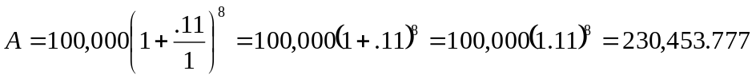

Keystrokes: 100000 × 1.11 8 ENTER

So, the price of the home in 1986 would have been approximately $230,453.78 n

It would seem that if the home owner in the previous example were to sell the house at the 1986 value of about $230,454, then he would make a hefty profit of $230,454 − $100,000 = $130,454. However, keep in mind that if the overall inflation rate were also 11% per year, then the price of everything, not just houses, would have risen at 11% per year, so, this profit might be an illusion. (Why?)

Tip: Looking for A or P? When solving an inflation problem with the compound interest formula, it is sometimes confusing whether you have been given A and should solve for P, or the reverse. One way to settle this issue is to ask yourself whether you are looking for the larger or smaller of these two amounts. Since the amount P grows into the amount A, P is always the smaller of these two amounts. Examples 2 and 3 should make this clear.
B

Example 2: The current price of a Chevy sedan is $22,000. Assuming that the price of sedans rose by 8.0% per year over each of the last ten years, what would have a comparable sedan cost ten years ago? By how much did the price increase over those ten years?

Solution: This problem can be solved using the compound interest formula with n = 1. But
are we looking for A or P? Since we are looking for the price of the car ten years ago
and (and under inflation) we expect this to be smaller than the current price of $22,000, we
must be looking for P (the smaller of A and P). So, we have the following substitutions.

P = ? A = $22,000
r = 0.08 i = .08/1=.08
n = 1 N = nt = 1(10) = 10
t = 10

We can algebraically manipulate the compound interest in advance to solve for P:

⇒ 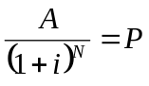 ⇒

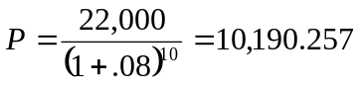

Thus, ten years ago, a comparable sedan would have cost about $10,190.26. The increase in
the price over the ten-year period was $22,000.00 − $10,190.26 = $11,810.74 . n

Everyone should be able to figure out whether or not their salary increases are keeping up with inflation, as in the next example.

Example 3: Suppose that, over a three-year period, you had end-of-the-year salary increases as below and that inflation ran as indicated below for those years. Did your salary keep up with inflation? Assume that your salary at the beginning of 1992 is $30,000.

Year Salary Increase Inflation
1992 5.0% 7.0%
1993 6.2% 4.9%
1994 4.7% 3.1%

Solution: We will stop the clock at the end of each year and make two calculations: the actual salary and the salary you would have if the pay raises were set exactly equal to the inflation rate. Think of this as the comparison of two pay raise schemes and then, at the end, ask yourself which plan you would rather be on.

End of Year 1
Actual salary = 30,000 (1.05) = $31,500
Inflationary salary = 30,000 (1.07) = $32,100
Note that, so far, your salary is not keeping up with inflation.

End of Year 2
Actual salary = (previous actual salary) (1.062) = 31,500 (1.062) = $33,453.
Inflationary salary = (previous inflationary salary) (1.049) = 32,100 (1.049) = $33,672.90
Again, your salary is a little behind inflation.

End of Year 3
Actual salary = (previous actual salary) (1.047) = 33,453 (1.047) = $35,025.29
Inflationary salary = (previous inflationary salary)(1.031) = 33,672.90(1.031) = $34,716.76

By the end of 1994, your salary has slightly passed the inflationary salary, so, yes, your salary has kept up with inflation (and then some).

Alternate solution [shorter]: The salary increases for the three years were 5.0%, 6.2% and 4.7% respectively. The effect on the salary is to increase it by the factor:

(1.05)(1.062)(1.047) = 1.1675097

This means that the overall salary increase is 16.75%.

The inflation increases for the three years were 7.0%, 4.9% and 3.1% respectively. The effect on prices is to increase them by the factor:

(1.07)(1.049)(1.031) = 1.15722533

Therefore, the overall inflation rate is 15.72%. Since the actual salary increase (16.75%) is higher, we see that the salary has kept up with inflation. n

Example 4: Some South American countries such as Chile and Brazil have suffered severe inflation in past decades, often at rates of 20 - 90% per year. When prices rise this quickly, it is more practical to quote inflation rates as monthly rather than annual. Suppose that the United States were to experience an inflation rate of 5.4% per month for every month over a two-year period. What effect would this have on, say, the price of a gallon of gasoline? Specifically, how much would a gallon of gasoline cost at the end of the two-year period if it costs $1.20 to start?

Solution: One way to solve this problem is to increase $1.20 by 5.4% (multiply by 1.054), then increase that quantity by 5.4% (multiply again by 1.054), and so on, for a total of 24 times (there are 24 months in a two-year period). This is the same as multiplying $1.20 by the factor (1.054)²⁴. That is,

Price after 24 months = 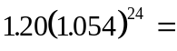4.239902864.

Thus, a gallon of gasoline would cost about $4.24 after the two-year period.

Another approach is to use the compound interest formula. However, you must be careful to convert the monthly interest rate to an annual interest rate. This can be accomplished by multiplying by 12. Thus, r = .054(12) = 0.648. Also, n should be set to n = 12 (monthly compounding). This will yield the same answer as before. n
Problems

- Assuming that inflation of boat prices will be 4.0% for each of the next six years, how much will an $18,000 boat cost six years from now?

- Suppose that the inflation rate over each of the last ten years was 5% and that a Mini-Van costs $24,000 right now. How much would a comparable vehicle have cost ten years ago?

- Silver quarters minted prior to 1933 have appreciated at the rate of 11% every year since their minting. How much is a 1929 quarter worth in 1995? Note that a quarter was worth $0.25 in 1929 !

- In the Boston metropolitan area, the prices of houses were rising at an average of 12% per year for each of the years between 1977 and 1987. If a house were purchased for $75,000 at the start of 1977, how much would it have been worth at the start of 1987?

- Determine whether or not one's salary has kept up with inflation at the end of the three-year period under the following pay raise scheme (use $40,000 as the starting salary):

Year Pay raise Inflation
Year 1 6.0% 5.5%
Year 2 5.3% 6.2%
Year 3 4.9% 4.3%

- Approximately how many years will it take for a $100 coat to cost $200 if inflation will run at 7.0% per year? Compute t to two decimal places. (Hint: Try different values of t until you get close to $200).

- The median annual income for a family of four in the United States in 1995 was $28,000. Assuming that inflation ran at an average of 5.0% per year for each of the prior 50 years, what would the median income have been in 1945?

- Suppose that the cost of homes in your area will inflate at the rate of 11% per year indefinitely. How many years will it take for your home to triple in price? (Note: you don’t need to know how much your home is worth to answer this question but you can make one up, if you wish).

- The cost of a first-class postage stamp in 1997 was 32 cents. If inflation from 1897-1997 was constant at 3% per year, how much was a first-class stamp worth in 1897?

- In 1995, Jeff had an opportunity to buy an antique clock costing $10,263.23. Instead, Jeff deposited exactly $10,263.23 into an account that paid 4% interest compounded daily. Suppose that the antique clock appreciates in value by 8% each year, and that Jeff’s interest rate remains at 4% over the following 7 years. After 7 years (in 2002), how much will Jeff have in the account and how much will the clock be worth? Should he have bought the clock?

- Over the past 10 years, the value of a first-issue comic book rose 4% each month. If the comic book was originally (10 years ago) worth $1.00, how much is it worth now? [Note: 4% is a monthly rate, not an annual rate]

- The value of a share of Ramtron Computer Co. stock appreciates at the rate of 0.4% per week. If a investor initially holds $25,000 of the stock, how much will her stock holdings be worth after 1 year?

Web

- Find the average increase in the (monthly) Consumer Price Index (CPI) over the last two years. Use this information to compute how much a worker whose salary two years ago was $36,000 must be earning today in order for his salary to have kept up with inflation. This is best done on a spreadsheet. Increase the worker’s salary for each of the 24 months at exactly the corresponding inflation rate.

Solutions

- The boat will cost $22,775.74.

- The mini-van would have cost $14,733.92

- In 1995, the quarter is worth about $245.05.

- The house would have been worth about $232,938.62.

- Salary Inflation
End of year 1: $42,400.00 $42,200.00
End of year 2: $44,647.20 $44,816.40
End of year 3: $46,834.91 $46,743.51 ⇐ Yes, it kept up

- It will take about 10.25 years for the price of the coat to reach $200.

- The median income would have been $2,441.70

- Believe it or not, it will only take about 10.5 years for the house to triple in price!

- The stamp was worth about 1.7 cents.

- In 2002, Jeff will have a balance of $13,579.38 and the clock will be worth $17,589.37. Jeff probably should have bought the clock.

- The comic book is now worth $110.66.

- Her stock holdings will be worth $30,767.56.

1.5 Increasing Annuities

An increasing annuity is an interest-yielding account in which regular deposits are made for the purpose of accumulating money. When the deposits are of equal size and made at the end of a compounding period, then the increasing annuity is called ordinary. For the sake of simplicity, we will deal primarily with ordinary annuities.

If you deposited, say, $200 per month into an annuity that yielded no interest, then it would be a simple matter to compute the amount of money you would have after 10 years: just add up all the deposits that were made (multiply $200 times 120 months). But if the bank is adding interest every month, then the calculation is not so simple. Fortunately, the increasing annuity formula, below, can be used to compute the future amount A (balance) in an annuity, once the deposit size D is known. Also, it can be used in reverse to find the deposit size D that you would need to acquire a specified future amount over a fixed amount of time.

Increasing annuity formula
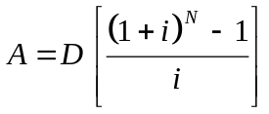

where,

A = future amount N = nt
D = amount of deposits i = r/n

Warning: This formula is valid only when (1) the deposits are made at the end of each compounding period, (2) the account starts with a zero balance, and (3) the deposits are being made at the same frequency as the compounding (e.g., monthly deposits, monthly compounding).

Examples 1 and 2 will demonstrate the use of the increasing annuity formula. Example 3 uses a spreadsheet to answer more detailed questions regarding increasing annuities. Also, using a spreadsheet releases you from some of the restrictions imposed upon the increasing annuity formula in the warning above.
Example 1:
(a) Suppose that you have an account that pays 10.0% interest, compounded monthly, and that you wish to make monthly deposits of $500.00 (end of the month). How much money will be in the account at the end of six years?
(b) How much interest will you earn on the account?

Solution: (a) Even though it was not mentioned explicitly, the account is an (ordinary) increasing annuity because there are regular deposits being made into an account. [Also, we assume a zero starting balance.] We will use the increasing annuity formula with D = 500.00, r = 0.10, n = 12 (monthly deposits and compounding) and t = 6. We are looking for the future amount, A. Thus, we have

A = ?
D = 500
N = 12(6) = 72
i = .10/12

Calculator Tip: Compute the quantity i in advance and store it in memory in your calculator. (The memory recall button for memory varies from calculator to calculator, so we will continue to call this number i in our keystrokes.)
B

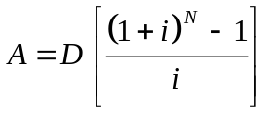 ⇒ 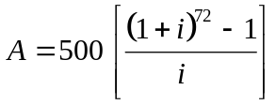

Keystrokes: It will help here to store the quantity i in memory.
500 ( ( 1 + i ) 72 − 1 ) i ENTER

We obtain A = 49,055.65681. So, there will be $49,055.66 in the account at the end of six years.

(b) Since the bank is periodically adding interest to an increasing annuity, the final balance is more than the sum of the deposits. The difference is exactly the amount of interest the bank put in (think about it). That is,

Total interest = Future amount − Sum of deposits

We already know the future amount, but what is the total of the deposits? You will have made one deposit per month for 6 years for a total of 12 × 6 = 72 deposits. Each deposit was $500, so the sum of the deposits is 72(500) = 36,000:

Total Interest = $49,055.66 - $36,000.00 = $13,055.66. n

Example 2: Mr. Goldberg wishes to retire in 23 years and have $100,000 saved in his retirement account that pays 12% interest, compounded monthly. Assume that his account starts with a zero balance.
(a) How much money should he deposit into the account (at the end of) each month?
(b) How much interest will be earned on the account over the 23-year period?

Solution: (a) Mr. Goldberg will be using his account as an increasing annuity. We are looking for the variable D in the increasing annuity formula.

We set A = 100,000, r = 0.12, n = 12 and t = 23 so that

A = 100,000
D = ?
N = nt = 12(23) = 276
i = .12/12 = .01

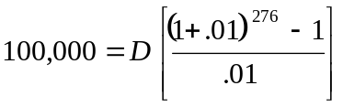

Keystrokes: To compute the fraction in the square brackets
( ( 1 + .01 ) 276 − 1 ) .01 ENTER
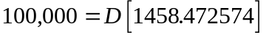

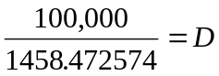

We obtain D = 68.56488204. In other words, Mr. Goldberg would need to deposit only $68.56 per month in order to save $100,000 over 23 years. This seems too good to be true! But we must remember that 12.0% is a generous interest rate and that the deposits are being made over a very long period of time. This astounding accumulation is due to the long-term compounding effect.

(b) To find the total interest, we will subtract the sum of the deposits made by Mr. Goldberg from the final balance in the account. Since he deposited $68.56 per month for 23 years, he has deposited a total of ($68.56)(12)(23) = $18,922.56. Thus,

Total interest = Future amount − Sum of deposits = $100,000.00 - $18,922.56 = $81,077.44

That's a lot of interest! Mr. Goldberg increased his money by more than four times. This shows the power of long term savings. n

Example 3: Consider Mr. Goldberg’s increasing annuity from Example 2. Suppose that he wishes to open his increasing annuity account with an initial deposit of $10,000 and retain the flexibility of increasing his deposit amount. In fact, he anticipates depositing $500 per month for the first four months, then increases the deposit to $600 for the next three months.

(a) Construct a spreadsheet that will track the monthly balance of his account for the first seven months of the annuity.
(b) How many months will it take for the balance on the annuity to exceed $13,000 ?
(c) How many months will it take for the total interest to exceed $425?

Solution: (a) We will construct a spreadsheet that will show the balance in the account at the end of each of the seven months (this could also be done on paper with the help of a calculator). We will need columns as below.

Month | Balance start | Interest earned | Deposit | Balance end
1
2
3
4
5
6
7

We enter the initial balance, $10,000, and the deposit amount for each month.

Month | Balance start | Interest earned | Deposit | Balance end
1 | 10,000.00 |  | 500.00
2 |  |  | 500.00
3 |  |  | 500.00
4 |  |  | 500.00
5 |  |  | 600.00
6 |  |  | 600.00
7 |  |  | 600.00

The interest earned for the first month is computed with the simple interest formula, I = Prt, where P is the amount of money that has been in the account for month 1, namely, $10,000. We set r = .12 and t = 1/12 (one month is one-twelfth of a year):

I = Prt = $10,000(.12)(1/12) = $100

Thus, he will earn $100.00 in interest in the first month. We record this in the "interest earned" column.

Month | Balance start | Interest earned | Deposit | Balance end
1 | 10,000.00 | 100.00 | 500.00 | 10,600.00
2 |  |  | 500.00
3 |  |  | 500.00
4 |  |  | 500.00
5 |  |  | 600.00
6 |  |  | 600.00
7 |  |  | 600.00

The ending balance for the first month is the sum of the starting balance, the interest earned for the month and the deposit made (at the end of the month):

10,000 + 100 + 500 = 10,600

We enter this amount in the “Balance end” column for month 1 and it carries over to the “Balance Start” column for the month 2.

Month | Balance start | Interest earned | Deposit | Balance end
1 | 10,000.00 | 100.00 | 500.00 | 10,600.00
2 | 10, 600.00 |  | 500.00
3 |  |  | 500.00
4 |  |  | 500.00
5 |  |  | 600.00
6 |  |  | 600.00
7 |  |  | 600.00

Similarly, the interest earned for month 2 is computed using the starting balance of 10,600:

I = Prt = $10,600(.12)(1/12) = $106

This amount is entered in the interest column, added to the starting balance and the deposit amount to arrive at an end-of-the month balance of $11,206:

Month | Balance start | Interest earned | Deposit | Balance end
1 | 10,000.00 | 100.00 | 500.00 | 10,600.00
2 | 10, 600.00 | 106.00 | 500.00 | 11,206.00
3 | 11,206.00 |  | 500.00
4 |  |  | 500.00
5 |  |  | 600.00
6 |  |  | 600.00
7 |  |  | 600.00

The rest of the spreadsheet (or table) is completed in a similar fashion. At the bottom of the spreadsheet, we have summed the interest column and the deposit column to obtain the total interest and the total of the deposits.

Month | Balance start | Interest earned | Deposit | Balance end
1 | 10,000.00 | 100.00 | 500.00 | 10,600.00
2 | 10,600.00 | 106.00 | 500.00 | 11,206.00
3 | 11,206.00 | 112.06 | 500.00 | 11,818.06
4 | 11,818.06 | 118.18 | 500.00 | 12,436.24
5 | 12,436.24 | 124.36 | 600.00 | 13,160.60
6 | 13,160.60 | 131.61 | 600.00 | 13,892.21
7 | 13,892.21 | 138.92 | 600.00 | 14,631.13
 | Totals: | 831.13 | 3,800.00

Now we are ready to answer the questions to parts (b) and (c) of this problem.

(b) To find the number of months it will take for the balance on the annuity to exceed $13,000, we can scan down the end-of-the-month balance column until it first exceeds $13,000. The first month this happens in is month 5. So, it would take five months.

(c) To find the number of months it will take for the total interest to exceed $425, you can scan down the interest column until the sum of the entries exceeds $425. This happens at the fourth month (total interest earned = $436.24).

Problems

Note: In each of the problems below, assume that the deposits are being made at the end of the compounding period.

- The Skvarcius’ will save for their daughter’s college education by making monthly deposits in a savings account that yields 8.9% interest per year, compounded monthly. They estimate that they will need $32,000 for her education, 12 years from now. How much should the deposits be?

- If you deposited only three dollars per week into a savings account that yields 5.5% interest per year, compounded weekly, (a) how much money would you have saved in 30 years? (b) how much would you have deposited total? (c) how much interest will you have made?

- Mr. Quarg has set up an increasing annuity that yields 12% interest per year, compounded quarterly. He will deposit $250 into the account every quarter of a year for the next 10 years. How much will the annuity be worth at the end of the 10-year period?

- Congratulations, you have just won the state lottery jackpot of one million dollars! However, rather than pay you in one lump sum, the state will pay you $50,000 per year for the next 20 years. Make two calculations: (a) find the amount the 1 million dollars would be worth in 20 years if you could receive it all now and invest it at a modest 6% per year, compounded annually and (b) find the amount the 1 million dollars would be worth if you set up an annuity paying 6% per year, compounded annually, and deposited the $50,000 per year in the annuity. (c) How much interest would you make in each of the previous scenarios? (d) Assuming an average inflation rate of 4.5% for each of the coming 20 years, how much will the last $50,000 be worth in present dollars? [Hint: It should be worth less] (e) Use parts (a) and (b) to decide whether or not the state “really” gave you one million dollars.

- Suppose that you deposit $100 per month into an account that pays 7.0% interest per year, compounded monthly, for the next 10 years. Then, you make no further deposits but let the money sit and accrue interest. (a) How much will be in the account after a total of 15 years? (b) How much interest will be made on the account? (Hint: First, calculate the interest made on the annuity, then on the compounding for the remaining five years).

- An employee deposits $60 at the end of each month in a credit union savings plan that pays an annual percentage rate of 6%, compounded monthly. What is the balance at the end of six months? (a) What monthly deposit amount will produce a balance of $100,000 after 45 years? Assume that the annual percentage rate is 7.0%, compounded monthly. (b) What is the total amount deposited over the 45-year period?

- Complete a spreadsheet (or construct a table by hand) that shows the monthly analysis of a six month increasing annuity paying 12% APR, compounded monthly with monthly deposits of $200.00.

- Use a spreadsheet (similar to the one in the problem 8) to solve the following problem: Over a period of 6 years, Murph deposited the following amounts into a retirement fund: end of year 1: $1500, end of year 2: $4100, end of year 3: $2000, end of year 4: $2312, end of year 5: $6000, end of year 6: $5000. If his fund paid 6.5% interest compounded annually, calculate the total interest that Murph made over the 6-year period.

- Each day for the last 5 years, Brian deposited 25 cents into his savings account at First Maryland Bank. If First Maryland pays him 4.5% APR, compounded daily, (a) How much does Brian have in his account now? (b) How much total has he deposited? (c) How much total interest has he made?

- Mr. Yang has $12,000 in an account paying 5% interest, compounded monthly. For the next 10 ½ years, he will deposit $250 into his account at the end of each month , (a) How much will he have in the account at the end of the 10 ½ year period? [Hint: Break this into two separate problems.] (b) How much interest will Mr. Yang make?

- How much should you deposit each week into an increasing annuity paying 8% interest, compounded weekly, if you would like to have a balance of one million dollars after 30 years?

- Susan Quanto’s credit union savings plan takes $60 each month from her paycheck and deposits it into her savings plan which pays 6.25% APR, compounded monthly. Create a spreadsheet to display the following account information for each month over a 2-year period: initial balance, interest for the month, deposit amount, and ending balance. How much total money will be deposited? How much interest will be made over the 2-year period? How long will it take for the (end of the month) balance to exceed $950.00?
7

Web

- Life Insurance. Visit the website http://www.lifenet.com/termcost.html and use the sample rate calculator to determine your monthly fee for a $100,000 basic life insurance policy. Now suppose that instead of buying life insurance, each month you set aside the amount of the payments into an annuity paying 7.6% interest, compounded monthly.
- Use a spreadsheet to see how long it will take until the annuity achieves a balance of $100,000.
- Explain whether or not you feel this life insurance policy would be a good option for you. You may want to take your life expectancy into account, for instance, what if you do not live very long?

7
Solutions

- Each deposit should be $125.04.

- (a) $11,919.65 (b) $4680.00 (c) $7239.65

- Mr. Quarg's account will be worth $18,850.31.

- (a) $3,207,135.47 (b) $1,839,279.56 (c) first: $2,207,135.47, second: $839,279.56
$20,732.14 (e) It would be much better if the state gave all of the money up front.

- (a) $24,536.94 (Note: There is $17,308.48 after 10 years - compound this for 5 more
years to obtain the answer) (b) Interest = $12,536.94

- The six month balance is $364.53.

- (a) Monthly deposit amount: $26.37 (b) Total amount deposited: $14,239.80

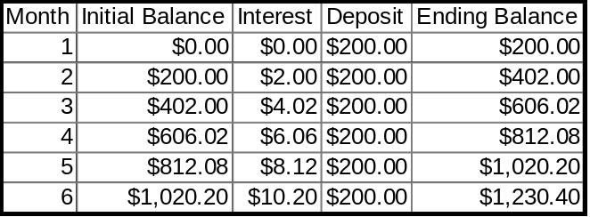

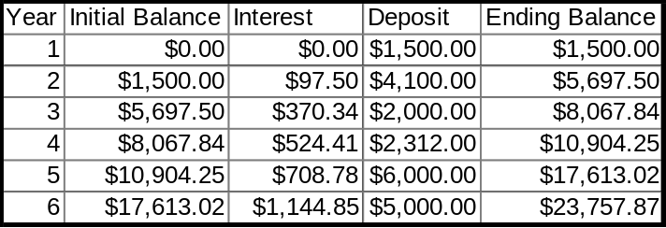

Total interest that Murph made is $2,845.87.

- (a) Brian will have $511.62. (b) He deposited a total of $456.25. (c) He made $55.37 in interest.

- (a) Mr. Yang will have $20,263.39 from the money that was initially in the account and $41,316.96 from the increasing annuity for a grand total of $61,580.35. The total amount that he will deposit into the account is given by the initial balance plus the sum of the payments: $12,000 + $250 (12)(10.5) = $43,500.00. From part (a), the final balance on the account will be $61,580.35. The difference between this figure and the sum of his deposits (including the initial deposit) is his total interest:

Total interest = $61,580.35 − $43,500.00 = $18,080.35

- You would have to deposit about $153.80 each week.

13.
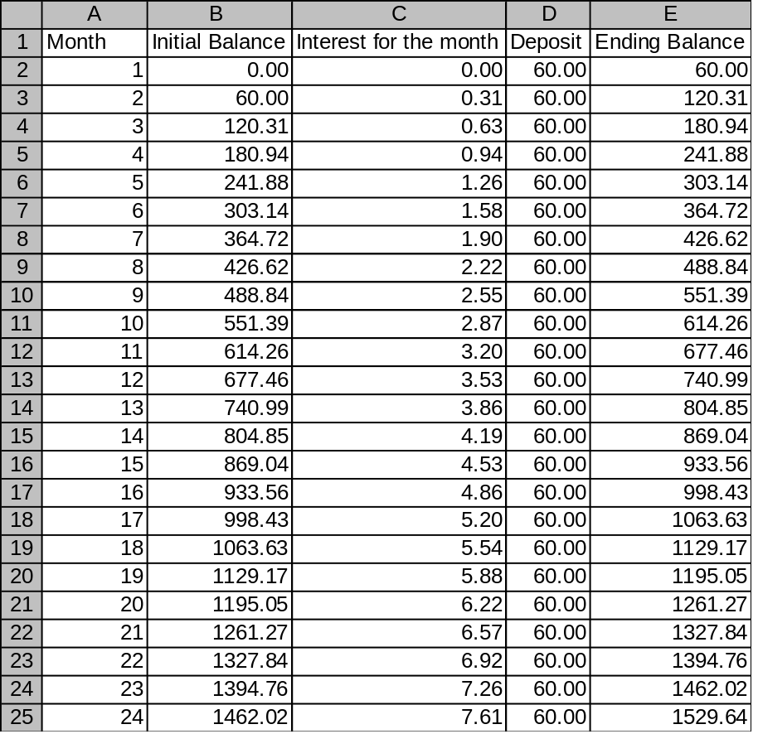

(b) There will be a total of $1440 deposited into the account.
(c) The account had a final balance of $1529.64, so the difference between this and $1440 $89.64 is the total amount of interest earned.
(c) It will take 16 months (1 year and 4 months).

1.6 Decreasing Annuities

Recall that an increasing annuity is an account into which one makes regular deposits. A decreasing annuity is an interest-yielding account from which one makes regular withdrawals. A decreasing annuity must have a starting balance, which we will call, P. The amount P limits how much money one can withdraw from an annuity. We will be computing the amount W that one can withdraw on a regular basis from an annuity so that the balance will drop from P to zero over some predetermined period of time. Also, the formula will be used to determine the initial balance P that is required to sustain withdrawals of size W over some predetermined period of time. As with the increasing annuity formula, the decreasing annuity formula brings with it certain restrictions (see the warning below the formula).

Decreasing annuity formula

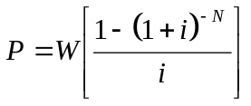

where, P = initial balance (principal)
W = amount of regular withdrawal
N = nt
i = r/n

Warning: This formula is valid only when the withdrawals are being made at the exact same frequency as the compounding. For instance, if you are making monthly withdrawals then the bank must be compounding the account monthly in order for the formula to work correctly. Also, we assume that the withdrawals are made at the end of each compounding period.

Example 1: Your wealthy Aunt Fifi has decided to set up an account for you so that you can make withdrawals at the end of each week for the remaining three years of your college education. Aunt Fifi is gullible enough to believe that you require $200 per week.

(a) If the account pays 8.0% per year, compounded weekly, how much money should she deposit into the account at the start of the three years?
(b) How much total money will be withdrawn from the account over the three year period?
(c) How much interest will be made off of the account?

Solution: (a) The amount of the withdrawal has been fixed at $200 but the amount of the starting balance is undetermined. So, in the decreasing annuity formula, we are looking for the variable P. The banking information is set at r = .08, n = 52 (weekly withdrawals) and t = 3. Thus, we have

P = ?
W = 200.00
i = .08/52
N = nt = 52(3) = 156

⇒ 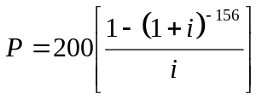

Calculator Tip: Compute the quantity i in advance and store it in memory in your calculator.
B

Keystrokes: Note: (−) is the change-of-sign key, not subtraction. On some calculators, this key appears as ±.
1 − ( 1 + i ) (−) 156 ENTER (this computes the numerator of the fraction)
i ENTER 200 ENTER

We obtain P = 27,719.51662. Aunt Fifi will need to deposit a whopping $27,719.52 into the account.

(b) The total money withdrawn from the account is the sum of the withdrawals.

Total of withdrawals = (amount of withdrawal) (total number of withdrawals)
= $200 156
= $31,200

You will take a total of $31,200 out of the account over the three-year period.

(c) The total interest earned on the account is the sum of the withdrawals minus the starting balance:

Total interest = (sum of withdrawals) − (starting balance)
= $31,200 − $27,719.52
= $3,840.48 n

Note that in every decreasing annuity, the total of the withdrawals ($31,200, in the previous example) is more than the amount of the deposit ($27,719.52, in the previous example). How can this be? The bank makes up the difference with interest!

Example 2: Gretta Gooch will have $200,000 in her savings account when she retires at age 65. At that time, she will start making withdrawals at the end of each month to support herself. For budgeting purposes, she would like all the withdrawals to be an equal amount.

(a) If the account pays 10.0% interest per year, compounded monthly, how much can she expect to withdraw each month so that her account lasts until age 89?
(b) How much interest will she make on the account over the 24 year period?

Solution: (a) Since Gretta will be making regular withdrawals from her savings account she will be using it as an annuity, even though it is not formally labeled as one. The annuity will last a total of 89 − 65 = 24 years. We are looking for the withdrawal amount, W, in the decreasing annuity formula. The amount of the initial deposit, P, has been fixed at $200,000. Thus, we have the following substitutions:

P = 200,000
W = ?
i = .10/12
N = nt = 12(24) = 288

⇒ 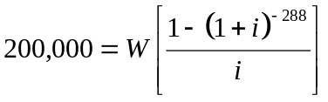

Tip: Compute the quantity i in advance and store it in memory.
B

Keystrokes: Note: (−) is the negative key, not subtraction
1 − ( 1 + i ) (−) 288 ENTER (this computes the numerator of the fraction)
i ENTER

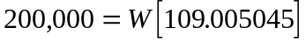

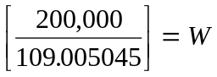

We obtain W = 1834.777464. That is, Gretta can withdraw about $1834.78 at the end of each month.

(b) To compute the total interest that Gretta will make on the annuity, we will compute the total amount she will withdraw, then subtract from it the amount P that she will deposit at age 65. First, we compute the total amount she will withdraw. Gretta will make one withdrawal every month (twelve times per year) for 24 years. That’s a total of (12)(24) = 288 withdrawals. Each withdrawal was in the amount $1834.78, so she will withdraw a total of ($1834.78)(12)(24) = $528,416.64 from the account. Her one-time deposit was $200,000. Thus,

Total interest in a decreasing annuity = Sum of withdrawals − sum of deposits
= $528,416.64 − $200,000
= $328,416.64 n

The previous example demonstrates the power of investing in a decreasing annuity upon retirement: Gretta increased her investment by a factor of more than 2.6 (from $200,000.00 to $528,416.64). The next example shows the wisdom of building up to a decreasing annuity with an increasing annuity. Pay particular attention to parts (b), (c) and (d), which show how well this pays off.

Example 3: Suppose that you wish to retire 30 years from now and live off of your savings for 25 years thereafter. You estimate that you will require $2000 per month for every month of retirement. To this end, you have set up an annuity that yields 8% per year, compounded monthly. Your plan is to make monthly deposits into the annuity (account) until retirement, then to drain the account with monthly withdrawals of $2000 over the subsequent 25 years.

(a) How much should you deposit into the annuity each month until retirement?
(b) How much total money will have been deposited into the account?
(c) How much will be withdrawn?
(d) How much interest will be made on the account?

Solution: (a) For the first 30 years, the annuity will be increasing (via regular deposits) but then, after retirement, it will be decreasing (via regular withdrawals). We would like to solve for the amount of each deposit, which is the variable D in the increasing annuity formula. Unfortunately, we have not been explicitly given the value of A. But this amount is the same as the principal P in the decreasing annuity (that is, A = P), which can be computed. This can be represented schematically, as below.

Balance
A = P

30 years of deposits 25 years of withdrawals

Retirement Plan

We begin with the decreasing annuity calculation.

Step 1: Decreasing annuity calculation

The amount of the regular withdrawals has been set at W = 2000 and we are looking for the amount P in the decreasing annuity formula. This will determine the amount that should be in the account upon retirement. The interest rate is r = .08 and the length of time of the decreasing annuity is t = 25 years. Our substitutions into the formula are as follows:

P = ?
W = 2000
i = r/n = .08/ 12
N = nt = (12)(25) = 300

⇒ 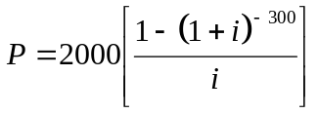 ⇒ 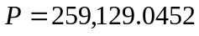

Keystrokes: Note: (−) is the negative key, not subtraction
1 − ( 1 + i ) (−) 300 ENTER (this computes the numerator of the fraction)
i ENTER 2000 ENTER

We obtain P = 259,129.0452. There should be about $259,129.05 in the account at the beginning of the 25-year retirement period, which is the same as the amount in the account at the end of the 30-year employment period (that is, A = $259,129.05).

Now that we have A, we are ready to return to our original goal, which is to solve for D in the increasing annuity formula.

Step 2: Increasing annuity calculation

We set A = 259,129.05, r = .08 and n = 12 in the increasing annuity formula. Note that the time interval is now t = 30 because the deposits are made over a 30-year period.

A = 259,129.05
D = ?
i = r/n = .08/ 12
N = nt = (12)(30) = 360

⇒ 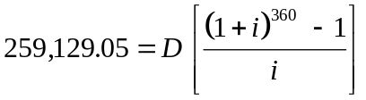

Keystrokes: To compute the fraction in the square brackets
( 1 + i ) 360 − 1 ENTER i ENTER

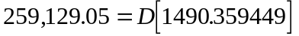

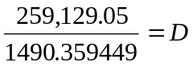

We obtain D = 173.8701628. That is, you will need to deposit about $173.87 into the account every month for 30 years.

(b) The total amount deposited into the account (over 30 years) is simply the sum of the deposits. Since $173.87 will be deposited 360 times (12 times per year for 30 years = 1230 = 360 times), the sum of the deposits is ($173.87)(360) = $62,593.20.

(c) Similarly, the total amount withdrawn from the account (over 25 years) is the sum of the withdrawals. There will be 300 withdrawals (12 times per year for 25 years = 1225 = 300 times) so this total is ($2000)(300) = $600,000.

(d) To compute the total interest that will be earned on the account, look at the answers to parts (b) and (c). $600,000 will be withdrawn from the account and yet only $62,593.20 will be deposited. How is this possible? The difference between these two figures must be the contribution made by the bank, namely, interest! That is, the

total interest = $600,000 − $62,593.20 = $537,406.80.

Not bad, for an investment of $62,593.20. n
Problems

Note: In each of the problems below, assume that the withdrawals are being made at the end of the compounding period.

- Your great Aunt Louise has left you an inheritance of $942,000. You plan to invest this into an account paying 5.5% interest, compounded monthly and to live off of withdrawals (equal sized) made at the end of the month until the account is depleted after 25 years. What sized monthly withdrawals can you make?

- J. Jenny Jablonski wants to know how much she should deposit now into an account paying 8.4% interest compounded daily so that she can withdraw $5.50 each day (for lunch money) for the next 4 years so that the account will be depleted at the end of the 4 years.

- Consider a decreasing annuity with a present value of $75,000. Find the total amount that can be withdrawn over a period of (a) 10 years (b) 20 years (c) 30 years. Assume that the withdrawals are monthly, compounded at 7.8%.

- Find (a) the initial deposit (b) the total amount drawn and (c) the total amount of interest for a decreasing annuity that pays 7.0% interest per year, assuming that $2000 withdrawals are made every year for 10 years.

- Re-do the problem 4 for an account that pays 5.5% interest, compounded monthly, assuming that monthly withdrawals of $500 are made.

- A self-employed person is planning a retirement program. The person is 35 years old and plans to retire at the age of 62. How much should be set aside each month in an annuity paying 8%, compounded monthly, in order to withdraw $2000 per month for 25 years?

- A person is planning a supplemental retirement program. The person is 40 years old and plans to retire at the age of 62. How much should be set aside each month in an annuity paying 7.75%, compounded monthly, in order to withdraw $1000 per month for 20 years?

- Assume that you have just deposited $10,000 into a decreasing annuity that yields 9.5% interest per year, compounded weekly. (a) How much money can you withdraw every week from the annuity so that it will run out of money in exactly four years? (b) How much total money will you withdraw from the annuity? (c) How much total interest will you make off of the annuity?

- Olivia has $10,000 in a money market fund paying 3% interest compounded monthly. Over the course of 6 months, she withdraws $500, $130, $621, $900, $580, and $422, respectively. Construct a table with columns as below to calculate her balance after 6 months.
7
7

- Phinehas Investment Co. has 1.5 million dollars in treasury bonds that pay 7% interest compounded annually. As the financial director of Phinehas, you decide to let the bonds sit for 5 years and then sell them off them in equal sized amounts each year for 15 years until they are all sold. (a) How many dollars worth of bonds should you sell each year to do this? (b) How much profit on these bonds will Phinehas make over the 20-year period?

- Mr. Taxicab Driver deposits $74,000 into an account that pays 3.25% interest compounded quarterly. He plans on withdrawing $4,000 at the end of each quarter. Use a spreadsheet to answer the following question. (a) How long will it take for his account to be depleted? (b) How long will it take until he has less than $30,000 left in the account? (c) How much interest will he make after 5 years?

- Ms. Hill deposits $10,000 into an account that pays 11.5% interest, compounded monthly. She plans on withdrawing $350 at the end of each month. Use a spreadsheet to answer the following question. (a) How long will it take for the account to be depleted? (b) How long will it take until she has less than $2000 in the account? (c) How much interest will she have made on the account after 2 years?
7

Thinkers

- Rounded Withdrawals. In Example 2, we said that Gretta withdraws about $1843.78 per month. Why can’t Gretta withdraw exactly $1843.78 at the end of each month?

Solutions

- You can make monthly withdrawals of $5784.70 for the next 25 years.

- J. Jenny Jablonski should deposit $6819.51 into the account to do this.

- (a)$108,246.00 [That’s $902.05 per month for 10 years]
(b) $148,324.80 [That’s $618.02 per month for 20 years]
(c) $194,364.00 [That’s $539.90 per month for 30 years]

- (a) The initial deposit = $14,047.16 (b) Total amount = $20,000 [That’s $2000 per year for 10 years] (c) Total interest = $5,952.84

- (a) The initial deposit = $46,071.79 (b) Total amount = $60,000 (c) Total interest = $13,928.21

- $259,129.05 will be needed in the account at retirement (this is P in the decreasing annuity formula). Using A = 259,129.05 in the increasing annuity formula, we obtain D = 227.03, so, the answer is $227.03 per month. [Be sure that you are using the correct values of t - we have two different values of t here, 25 and 27].

- $121,810.31 will be needed in the account at retirement (this is P in the decreasing annuity formula). Using A = 121,810.31 in the increasing annuity formula, we get D = 175.94 so, the answer is $175.94 per month.

- (a) Weekly withdrawals = $57.83 (b) Total withdrawals = $12,029.07 (c) Total interest = $2,029.07

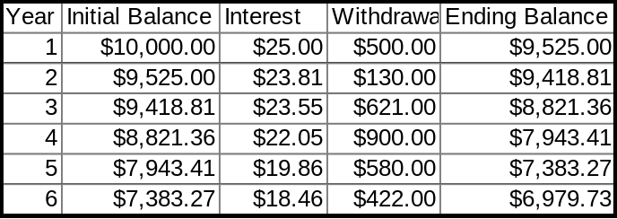

Final balance (after 6 months) is $6979.73.

- (a) You should sell $230,988.96 in bonds each year. (b) They will sell $3,464,834.40 in bonds for a net profit of $1,964,834.40.

- (a) It will be depleted in the 21st quarter (5 years and 3 months). In the 21st quarter, he will withdraw only $517.50.) (b) In the 13th quarter (3 years and 3 months). (c) He will make $6517.50 in interest.

- (a) The account will be depleted at the end of the 34th month. (b) The account balance will fall below $2000 on the 28th month. (c) The total interest earned after two years (24 months) will be $965.81.

1.7 Amortization

Amortization is the repayment of a loan in periodic payments. This is also known as an installment loan. Unless otherwise stated, we will assume that the payments (installments) are of equal size. Even though this is not the most efficient way to repay a loan, it has become a common way to repay home mortgages and car loans, presumably because consumers live with a fixed budget every month and require uniform payments. (Later, we’ll see a better way to repay a loan.) The common questions here will be (1) how much will the payments be on an amortized loan? and (2) how much can be borrowed once the payment amount is fixed?

Amazingly enough, we do not need a new formula to help answer these questions, we can use the decreasing annuity formula. This is because draining an account with regular withdrawals while interest accumulates is the same as draining a debt with regular payments while interest accumulates. That is, you can think of every payment as “withdrawing” a little bit of the debt. Recall that in the decreasing annuity formula, the variable P was the amount of the initial balance in the account. For amortization problems, P will represent the amount of the loan (balance due upon inception) and W will represent the amount of the regular payments.

Amortization (Decreasing annuity) formula

where, P = principal (amount of loan)
W = amount of regular payment

Note: This formula assumes that all payments (withdrawals) are made at the end of the compounding period.

Example 1 :
(a) What will the monthly payments be on a 36-month car loan of $18,000, if the interest rate is 9.2%, compounded monthly?
(b) How much total interest will be paid on the loan?

Solution: (a) Since this problem involves regular payments made on a loan, we will use the amortization (decreasing annuity) formula to solve it. We are looking for the amount of the monthly payments, which is the variable W in the formula. The amount of the loan is fixed at P = 18,000. The conditions of the loan are r = 0.92, n = 12 and t = 3 years (that’s 36 months - don't set t = 36 !). Thus, we have

P = 18,000
W = ?
i = r/n = .092/12
N = nt = (12)(3) = 36

⇒ 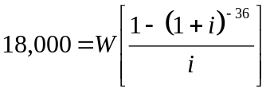

Keystrokes: Note: (−) is the negative key, not subtraction
1 − ( 1 + i ) (−) 36 ENTER (this computes the numerator of the fraction)

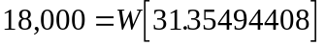

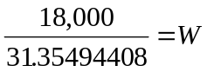

We obtain W = 574.0721449. So, the monthly payments will be about $574.07 each. Maybe we should find a cheaper car or get better financing!

(b) The total interest is the sum of the payments minus the amount borrowed. Since there will be a total of 36 payments (36-month loan) of $574.07 each, the sum of the payments will be (36)($574.07) = $20,666.52. Thus,

Total interest on amortized loan = (sum of payments) − (amount borrowed)
= $20,666.52 − $18,000
= $2,666.52

That is, the total amount of interest paid over the life of the loan will be $2,666.52. n

Example 2:
(a) The Cordwell family is shopping for a new home and they feel that they can afford a monthly mortgage payment of no more than $1200. The bank has offered a 7.0%, 25-year mortgage (compounded monthly). How expensive of a house can they afford to buy? Assume that they have $20,000 available for a down payment.
(b) How much total interest will they pay over the life of the loan?

Solution: (a) We will set W = 1200 in the amortization formula and solve for P. This will give the biggest mortgage that they can afford. If, for example, this amount turned out to be $100,000, then the Cordwell’s could afford to buy a $120,000 house, because they have $20,000 to put down. So, we set W = 1200, r = .07, n = 12, and t = 25. Our substitutions are

P = ?
W = 1200
i = r/n = .07/12
N = nt = (12)(25) = 300

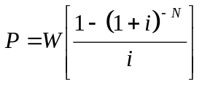 ⇒ 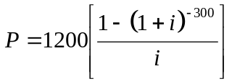

Keystrokes: Note: (−) is the negative key, not subtraction
1 − ( 1 + i ) 300 (−) ENTER (this computes the numerator of the fraction)
i ENTER 1200 ENTER

We obtain P = 169,784.284. The Cordwell’s can afford a mortgage of about $169,784. Adding the $20,000 down payment, we conclude that the Cordwells can afford a $189,784 house.

(b) The total interest paid over the life of the loan will be the sum of the payments minus the amount borrowed. They will make 300 payments (12 per year 25 years = 300) of $1200 each for a total of ($1200)(300) = $360,000.

Total interest on amortized loan = (sum of payments) − (amount borrowed)
= $360,000 − $169,784
= $190,216

That is, the total amount of interest paid on the $169,784 loan will be $190,216. n

In the opening paragraph to this section, we commented that amortization is not the most efficient way to repay a loan. Part of every payment goes toward paying off interest and the rest goes toward paying off the principal. On a long-term loan (e.g., home mortgage) there is so much interest due in the first few years that these early payments are mostly paying off the interest and very little of the principal. It would be better to make larger payments at the beginning of a loan then let the payments taper off (assuming negligible inflation). Let’s see why this is true.

Suppose that you have taken out a 30-year, $100,000 mortgage at 7.5%, compounded monthly. You can use the decreasing annuity formula to verify that your monthly payments will be $699.21.
It’s easy to compute how much interest you owe the bank at the end of the first month. You have held $100,000 of the bank’s money for one-twelfth of a year at 7.5%. Just use I = Prt with P = 100,000, r = .075 and t = 1/12:

I = Prt = (100,000)(.075)(1/12) = 625.00

That is, at the end of the first month, you owe $625 in interest. Your payment is fixed at $699.21, so, the amount that you are applying toward paying off the principal is

$699.21 − $625.00 = $74.21

That doesn’t do much to reduce a $100,000 debt! At the end of month 1, your balance has been reduced to $100,000 − $74.21 = $99,925.79. At the end of month 2, you have held $99,925.79 of the bank’s money for one month. So, the interest owed is

I = Prt = (99,925.79)(.075)(1/12) = 624.5361875

This means that $624.54 of your second payment is purely interest, while the rest,

$699.21 − $624.54 = $74.67

is applied toward the principal owed. The new balance at the end of month 2 will be

$99,925.79 − $74.67 = $99,851.12

You can see that there is little progress being made on repaying the principal in the first few months.

On a spreadsheet, we continued the breakdown for all 360 payments (months). To keep things brief, we have displayed only a small number of the payments.

Month | balance start | interest | principal paid | payment | balance end
1 | 100000.00 | 625.00 | 74.21 | 699.21 | 99925.79
60 | 94724.94 | 592.03 | 107.18 | 699.21 | 94617.76
120 | 86951.55 | 543.45 | 155.76 | 699.21 | 86795.79
180 | 75654.53 | 472.84 | 226.37 | 699.21 | 75428.16
240 | 59236.62 | 370.23 | 328.98 | 699.21 | 58907.64
300 | 35376.58 | 221.10 | 478.11 | 699.21 | 34898.47
359 | 1391.42 | 8.70 | 690.51 | 699.21 | 700.90
30-year, $100,000 home mortgage at 7.5%

Note that for every payment, the sum of the “interest” column and the “principal paid” column is the amount of the payment for that month, $699.21. For instance, in the 120th payment row you can see that

$543.45 + $155.76 = $699.21

This means that $543.45 of the $699.21 payment goes toward interest while the rest of the payment, $155.76, is applied toward reducing the balance on the loan (paying off the principal).

Scan down the “interest” column and see how the numbers drop. In contrast, as you scan down the “principal paid” column, the numbers rise because across any row, these two numbers must sum to $699.21. Note that on the second to last month (359), the amount of interest being paid is very small ($8.70) and that a large amount of the $699.21 payment (i.e., $690.51) is being applied toward the principal.

The reason that one owes so much interest early on and very little toward the end is straightforward. In the early months of the mortgage, you owe the bank a large amount of money! The only way around this is to pay off as much of the principal as early on as possible. Most banks will accept a payment larger than required. To see how effective it would be to pay even one dollar extra on your first payment, consider this: Every dollar that you do not pay on this first payment is held for the entire 30 years. At 7.5% interest per year, compounded monthly, that one dollar will compound over 30 years to (compound interest formula):

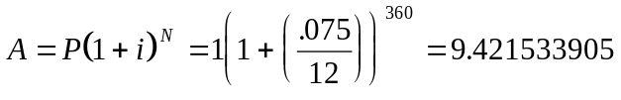

That is, every dollar that is not paid the first month will turn into about $9.42 owed at the end of the loan. So, repaying a mortgage as rapidly as possible makes good financial sense.

Problems

- Calculate the weekly payment required on a $3200 loan to be paid back over one year, compounded weekly at the rate of 16%.

- (a) How much will the monthly payment be on a five-year car loan that charges 8.1% interest (compounded monthly) if the amount borrowed is $12,000? (b) How much total interest will be paid over the life of the loan?

- (a) How much will the monthly payment be on a four-year car loan of $15,000 if the interest rate is 7.6% compounded monthly? (b) How much total interest will be paid over the life of the loan?

- Suppose that you are taking out a personal loan of $10,000. Which bank is offering a better bargain: a bank that offers a 36-month loan at 10.0% interest (compounded monthly) or a bank that offers a 48-month loan at 9.0% interest (compounded monthly)? Calculate the total interest that would be paid to each bank over the life of the loan before you give your answer. (Assume that both loans are amortized).

- A person takes out a monthly installment loan of $2000 with an annual percentage rate of 13.0%. If the person can afford no more than $70 per month, then which of the following terms are feasible? (a) 8 months (b) 12 months (c) 18 months (d) 24 months (e) 36 months.

- For each of the following installment (amortized) loans, calculate three things: the monthly payment, the total amount paid, and the total interest paid.
(a) $1500 to be repaid in 12 monthly payments at the APR of 20%
(b) $400 to be repaid in 6 monthly payments at the APR of 18.0%
(c) $20,000 to be repaid in weekly payments for 15 years at the APR of 9.0%

- A person wishes to borrow $20,000 and has the following options. One lending source offers the loan for 24 monthly payments at an annual percentage rate of 14%. The second source offers the loan for 18 monthly payments at an annual percentage rate of 16%. Which of these two payment schedules has the lower monthly payment?

- You just bought a motor boat for $12,000 and will put 20% down and finance the rest over two years. Your bank is offering a personal loan at the rate of 12% per year, compounded quarterly and asks that you make quarterly payments. (a) How much will the payments be? (b) How much will you pay in interest over the two years?

- Isaac bought a Plymouth Acclaim (automobile) in Pennsylvania for $22,000. When he registered it in his home state of Maryland, Maryland charged him a tax of 11.0%. He put 15% down on the car and is financing the rest (including the MD tax) over 3 years with monthly payments at 6.0%. Figure out how much the car will really cost him (interest plus down payment included). Be careful with your accounting.
7
7

- Calculate the total amount paid to the bank on a 30-year home mortgage of $100,000 at 9.0% APR, compounded monthly.

- Calculate the monthly payment and the total interest paid to the bank on a home mortgage of $110,000 if the interest rate is 7.8% (compounded monthly) and the loan is taken out for (a) 10 years (b) 20 years (c) 25 years (d) 30 years.

- Consider a home mortgage for $80,000 with monthly payments for 20 years. Find the monthly installments if the rate is (a) 8% (b) 9% (c) 12%.

- Mr. Larza was just about to take out a home mortgage of $120,000 for 20 years at the rate of 10.0% (compounded monthly). The monthly payments would have been $1158.00. But a competitive bank offered him a 30-year mortgage at 9.5% which has monthly payments of $1009.02. Mr. Larza went with the second bank because he assumed that a lower monthly payment and a lower interest rate would be a better bargain. Assuming that he could afford the higher payment, do you think he did the right thing? (Hint: Calculate the total interest paid on each of the two loans then compare).

- Consider an amortized loan of $10,000 (with 10.0% interest, compounded monthly) paid back over two years in equal, monthly installments. For each of the first two months, calculate three things: the interest paid for the month, the amount of the principal paid off and the balance at the end of the month.

- Suppose you took out a 6% home mortgage in the amount of $200,00 and that your monthly payments are $1500. (a) Use a spreadsheet to find out how long it will take you to pay off the mortgage. (b) How much will your final payment be?

- Gene makes a “deferred payment” loan of $50,000 at 7% interest compounded quarterly. He will make no payments for the first year then he will pay off the loan by making quarterly payments over the course of 8 years. How large will his payments be?

Web

- Use the web to find five 30-year mortgage offers with different rates and points. For each of these offers, compute the monthly payments, total interest and points paid to the bank over the life of a $100,000 mortgage. You might want to search with some combination of the words “mortgage”, “rate”, or “current”.

- Surf the web to find out what a “jumbo mortgage” is. Then, write one clear paragraph explaining what one is.

Solutions

- The weekly payments will be $66.69.

- (a) $243.89 per month (b) about $2,633.40 in interest

- (a) $363.38 per month (b) about $2,442.24 in interest

- The first bank’s payments would be $322.67 per month for 36 months - that’s a total of $11,616.20, or, $1,616.20 in interest. The second bank’s payments would be $248.85 per month for 48 months - that’s a total of $11,944.80, or, $1,944.80 in interest. So, the first bank is making a better offer, assuming one can afford the higher monthly payment.

- Monthly payments would be (a) $262.34 (b) $178.63 (c) $122.90 (d) $95.08 (e) $67.39
So, only (e) is feasible.

- (a) Monthly payment: $138.95 Total paid: $1,667.40 Total interest $167.40
(b) Monthly payment: $70.21 Total paid: $421.26 Total interest $21.26
(c) Monthly payment: $46.75 Total paid: $36,465 Total interest $16,465

- First monthly payment: $960.26 Second monthly payment: $1,257.19. The first one is lower.

- [Remember that you are financing only $9,600]. (a) Quarterly payments will be $1367.58 (b) Total interest will be $1,340.64.

- He needs to finance 85% of $24,420, which is $20,757. His monthly payments will be $631.47 so he will pay $22,732.92 to the bank over 3 years. The car is costing him $22,732.92 plus the down payment of $3,663, for a total cost of $26,395.92.

- Since the monthly payments will be $804.62, the total amount paid to the bank will be $289,663.20. [In essence, the mortgage will be paid for almost three times over!]

- (a) Monthly payment: $1,323.01 Total interest: $ 48,761.20
(b) Monthly payment: $ 906.44 Total interest: $107,545.60
(c) Monthly payment: $ 834.48 Total interest: $140,344
(d) Monthly payment: $ 791.86 Total interest: $175,069.60

- (a) $669.15 (b) $719.78 (c) $880.87

- The original bank would cost him $157,920 in interest. The other bank would cost him $243,247.20 in interest. No, going with the second bank is not a good idea in the long run, assuming that Mr. Larza could afford the higher monthly payment of $1158. This move will cost him an additional $85,327.20 in interest.

- The monthly payments are $461.45. Each payment gets split up into interest and principle as follows:
Month 1
interest paid: $83.33 principle paid: $378.12 balance at end of month: $9,621.88 Note: $83.33 + $378.12 = $461.45
Month 2
interest paid: $80.18 principle paid: $381.27 balance at end of month: $9,240.61 Note: $80.18 + 381.27 = $461.45

- It will take 221 months, or about 18.5 years to pay off the mortgage. (b) The final payment will be $407.63.

Gene will make quarterly payments of $2201.50

Unless otherwise stated, all interest rates will be annual percentage rates (APR).
There are various conventions for handling the special case in which the digit in the third decimal place is 5 and all others to the right of it are 0. For instance, the number 41.6750000 could be rounded to either 41.67 or 41.68. We have arbitrarily adopted the convention of rounding up in such cases.
It is commonplace to use 360 for the number of days per year instead of 365 (or 366, for a leap year). Historically, this number has been used to simplify calculations. Unless otherwise specified, we have chosen to use 365.
The irrational number e is second only to the number π. It appears in a surprising number of applications.
AER is not the same as APR. The former stands for annual effective rate (the percentage by which money grows in one year) while APR is annual percentage rate, the quoted rate r.
The word points is short for percentage points. Points are a one-time fee paid to the bank. For instance, 2 points means that you must pay 2% of the value of the loan up front.

