Smart Tire System
David Billet | Zach Panneton | Jason Saeedi

University of Maryland – College Park
ENME489P – Hands-on Systems Engineering
Spring 2011
Professor John Baras
Associate Professor Mark Austin

Abstract
This project focuses on improving active safety systems by utilizing advanced sensor mechanisms within a car's tire. A tire with sensors could provide useful data which would help the vehicle's control systems react to changing conditions and reduce the chance of accidents. An enhanced version of Vehicle Stability Control (VSC), where each corner of the vehicle is analyzed and accounted for separately would increase the ability of safety systems to adapt to changing environments. Such control systems would include:
- Sensor packages which lie within the tire.
- Communication devices to a receiver.
- A central control processor used to determine the proper adjustments to the vehicle.
- Electro-mechanical adjustment mechanisms to control engine torque, braking, suspension damping and spring rates, and alignment adjustments.
Specifically, this project will follow the flow of power and data at a systems level as road conditions are read, analyzed, and changes are made to mechanisms within the car in response to this data.

Table of Contents
Abstract 1
List of Figures 3
List of Tables 4
Problem Statement 4
Summary 4
Project Stakeholders 4
Visual Structure 5
Use Case Development 6
Primary Actors 6
Use Case 1: Installation 7
Use Case 2: Read condition of roads 8
Use Case 3: Detect abnormal conditions 8
Use Case 4: Modify vehicle characteristics 8
Textual Scenarios 10
Use Case 1: Installation 10
Use Case 2: Read conditions of roads 11
Use Case 3: Detect abnormal conditions 12
Use Case 4: Modify vehicle characteristics 13
Simplified Models of System Behavior 14
Use Case 2: Reading road conditions 14
Use Case 3 and 4: Detecting Abnormal Conditions and Modifying Vehicle Characteristics 15
Requirements Engineering 16
Traceability 25
Systems-Level Design 26
System Structure 26
Tradeoff Analysis 27
Weight and Power 27
Inductive Power Unit 29
Performance and Accuracy versus Cost 29
Summary and Conclusions 31
References 32
Sign-off Page 33

List of Figures
Figure 1: Tire Subsystem 5
Figure 2: Vehicle Subsystem 6
Figure 3: Relationship between Use Cases and Actors 7
Figure 4: Activity diagram for system installation 10
Figure 5: Activity diagram for reading road conditions 11
Figure 6: Activity diagram for detecting abnormal conditions 12
Figure 7: Activity diagram for modifying car characteristics 13
Figure 8: Sequence diagram for reading road conditions 14
Figure 9: Sequence diagram for detecting abnormal conditions, and modifying car characteristics 15
Figure 10: Sensor Note Physical Requirements 20
Figure 11: Sensor Node Component and Subsystem Requirements 21
Figure 12: Sensor Node Performance Requirements 22
Figure 13: Control Box Component and Subsystem Requirements 23
Figure 14: Control Box Performance Requirements 24
Figure 15: Smart Tire Structure Diagram 26
Figure 16: Power and Weight Requirement Diagram 27
Figure 17: Parametric Diagram Smart tire system 28
Figure 18: Verification Parametric Diagram 29
Figure 19: Voltage Versus # of Turns 29
Figure 20: Performance and Accuracy versus the number of sensors 30
Figure 21: Inductive Power Unit Exploded View 30

List of Tables
Table 1: Initial Requirements 16
Table 2: Detailed Requirements (Functional and Non-Functional) 17
Table 3: Component and Subsystem Requirements 18
Table 4: Requirement Details and Specifications 19
Table 5: Traceability of requirements to use cases 25

Problem Statement

Summary
Automobile accidents account for 25% of injury-related deaths worldwide. Better safety systems within vehicles would reduce the frequency and severity of accidents. Many current systems provide "passive" safety features, such as air bags and seat belts, which are designed to minimize injury in the case of an accident. Active safety features act to prevent accidents from ever occurring in the first place.
Many active safety features exist in cars and other vehicles, but many improvements are possible. However, any system is limited by the amount of information that is available to it. Ultimately, to become safer, additional information beyond what can be provided by current sensors is necessary.
Reading acceleration and other values directly from the tire of a vehicle can provide some of this additional information. By taking data near the contact patch between the tire and the road, very useful data such as coefficients of friction and real-time handling characteristics can be read. If successful, this project would improve car safety, car handling behaviors, and allow for potentially accident-free driving in the future.
This project analyzes the implementation of a ‘smart tire’ with data reading capabilities in cars and other wheeled vehicles at a systems engineering level.

Project Stakeholders
The main stakeholders for this project are drivers, car manufacturers, and tire manufacturers.
- Drivers: Drivers will be the ones purchasing and directly using the Smart Tire systems. They will receive additional functionality from their cars, including better vehicle stability control, adaptive car behaviors that should lead to improved ride conditions, and dashboard indications for dangerous conditions, tread ware, low pressure, etc.
- Car manufacturers: Car manufacturers may want to adapt their car designs to accommodate for Smart Tire systems. This will make their car more appealing to customers.
- Tire manufacturers: Tire manufacturers will need to adapt their tire designs to accommodate for the sensors, power generation, and wireless transmitter of the Smart Tire systems. This will make their tires more appealing to customers.

Visual Structure
The Smart Tire System is roughly divided into two parts: the sensor package within the tire, and the control system within the car. The tire will contain accelerometers, pressure sensors, and temperature sensors. Since the spinning tire cannot be physically coupled to the car, it will also need some means to generate its own power, and wirelessly transmit data back to the vehicle. The vehicle will have a signal processing box near each tire to receive the data, and a control box located in or near the vehicle’s computer to process the data and make adjustments to the vehicle’s characteristics as necessary. A representation of the tire subsystem can be found in Figure 1, and a representation of the vehicle subsystem can be found in Figure 2.
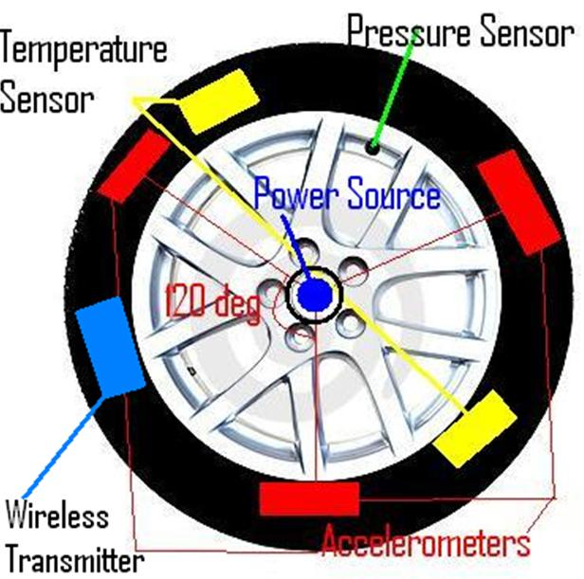
Figure 1: Tire Subsystem
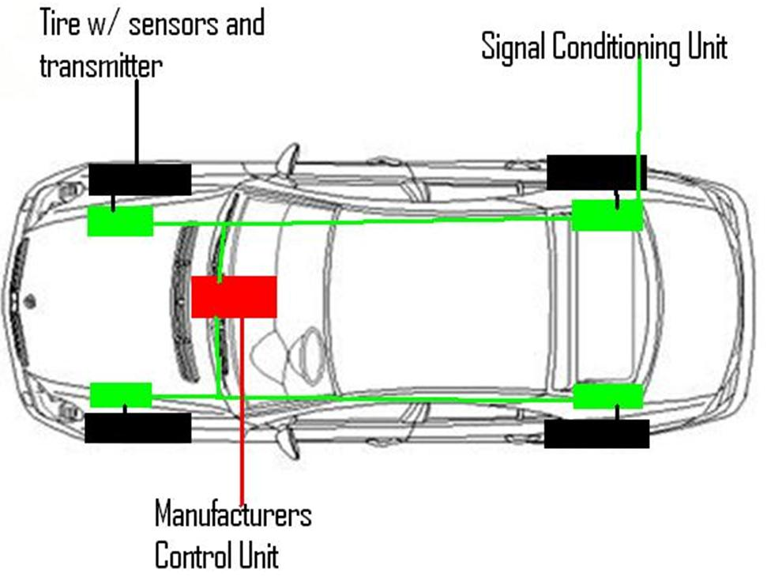
Figure 2: Vehicle Subsystem

Use Case Development

Primary Actors
- Mechanic: A mechanic will be necessary to install and test the system on the car.
- Road Conditions: The conditions of the road will impact the data that the sensors will be reading.
- Driver: The driver’s driving behavior will impact the data that the sensors will be reading. In addition, the driver may be notified of abnormal driving conditions.
- Control Box: The onboard computer within the vehicle that processes the data given to it by the Smart Tire system.
Figure 3: Relationship between Use Cases and Actors

Use Case 1: Installation
- Description: This use case simply details the installation of the Smart Tire system within a car. This will be necessary before the system can be used.
- Primary Actors: Mechanic
- Pre-Conditions: Mechanic must have the car, tire, and necessary software/computer system. In addition, they must have the tools and expertise necessary to install all required components.
- Flow of Events
  - The mechanic receives the tire with embedded sensors, as well as control hardware and/or software.
  - The mechanic installs the tires onto the car, ensuring any necessary wiring between the car and tire is done correctly. At the same time, they will install any control hardware or software necessary to read data from the sensors.
  - Once all components have been installed, the system will be tested to ensure that it works correctly.
    - If it works correctly, then the installation is finished.
    - If it does not work, then the mechanic must determine why and correct the problem.
- Post-Condition: The car is equipped with the Smart Tire System and is ready to be driven.

Use Case 2: Read condition of roads
- Description: This use case details the Smart Tire System in use as it reads the conditions of the road from its accelerometers, pressure sensors, and temperature sensors.
- Primary Actors: Road Conditions and Driver
- Pre-Conditions: Smart Tire System is correctly installed within the vehicle.
- Flow of Events
  - The sensors must be receiving power. This is accomplished by the motor within the tire, which should be providing sufficient power to the sensors whenever the car is in motion. If the car is not in motion, some power can be supplied by capacitors within the tire.
  - The active sensors measure the temperature, pressure, and accelerations within the tire.
  - The data is transmitted to a control box within the vehicle by a wireless transmitter. Here, the data is filtered and forwarded to the computer.
  - The computer reads and analyzes the data.
- Post-Condition: The vehicle’s computer now has the relevant data from the sensor package within the tire.

Use Case 3: Detect abnormal conditions
- Description: This use case details the detection of abnormal conditions by the onboard computer of the vehicle.
- Primary Actors: Road Conditions and Control Box
- Pre-Conditions: Sensor system must be reading road conditions and sending the data to the computer.
- Flow of Events
  - Computer receives sensor information
  - The pressure, temperature, and acceleration data from all four tires is read.
  - From the acceleration data, additional information is extracted, such as the coefficients of friction at the road contact.
  - Data is compared to expected values, or minimum/maximum allowable levels.
  - If data is not at the expected value, or beyond the minimum/maximum levels, then the car knows that there is some abnormal condition present.
- Post-Condition: Car will either continue operation as normal, or move on to modify vehicle characteristics if the car is behaving abnormally.

Use Case 4: Modify vehicle characteristics
- Description: This use case detail the modification of car characteristics in response to the detection of abnormal conditions by the vehicle’s computer.
- Primary Actors: Control Box, and Driver
- Pre-Conditions: Abnormal conditions detected.
- Flow of Events
  - Based on information from sensors, the control box has determined that non-normal conditions are present.
  - The control box notifies the driver that some abnormal condition is present.
  - The control box adjusts certain parameters of the car, such as engine power, power to wheels, spring ratios, damping ratios, etc.
- Post-Condition: Either the abnormal conditions will be corrected, in which case the car will resume normal driving behavior, or they will persist, in which case more adjustments and warnings will be given.

Textual Scenarios

Use Case 1: Installation
- When will this use case be triggered: This will happen when the tires are installed on the vehicle, or when the tires are changed.
- This must be done correctly, or the entire system will not function.
- Figure 4 describes this use case.
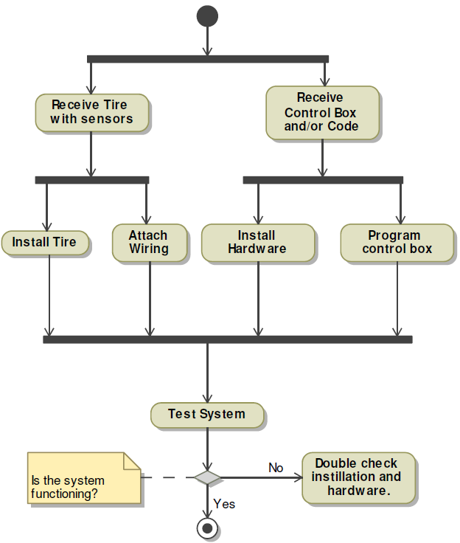
Figure 4: Activity diagram for system installation

Use Case 2: Read conditions of roads
- This use case will happen continuously.
- This may fail due to lack of power, or by a failure in the sensors or signal transmission. Failures can be detected by a loss of data or receiving inconsistent data in the control box. Power may be lost in low speed environments, in which case the computer will ignore the failure. Any other failures will prompt a notification to the driver.
- Figure 5 describes this use case.
Figure 5: Activity diagram for reading road conditions

Use Case 3: Detect abnormal conditions
- This use case will occur continuously.
- This should not fail for any reason. Failures might be due to damage to the vehicle’s computer or other electrical systems, in which case immediate repair would be necessary.
- Figure 6 describes this use case.
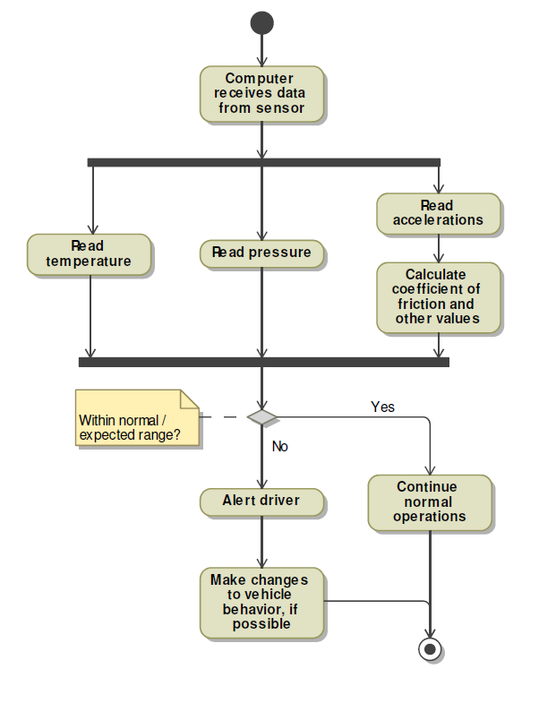
Figure 6: Activity diagram for detecting abnormal conditions

Use Case 4: Modify vehicle characteristics
- This use case will occur whenever abnormal conditions are detected.
- This should not fail for any reason. Failures might be due to damage to the vehicle’s stability systems or other physical systems, in which case immediate repair would be necessary.
- Figure 7 describes this use case.
Figure 7: Activity diagram for modifying car characteristics

Simplified Models of System Behavior

Use Case 2: Reading road conditions
Figure 8 shows a generalized sequence diagram of the sensor system as it reads road conditions and transmits data to the car’s computer.
Figure 8: Sequence diagram for reading road conditions

Use Case 3 and 4: Detecting Abnormal Conditions and Modifying Vehicle Characteristics
Figure 9 shows a generalized sequence diagram of the vehicle’s computer system receiving data, and making changes to the vehicle’s behavior.
Note that use cases 3 and 4 have been combined in this sequence diagram.
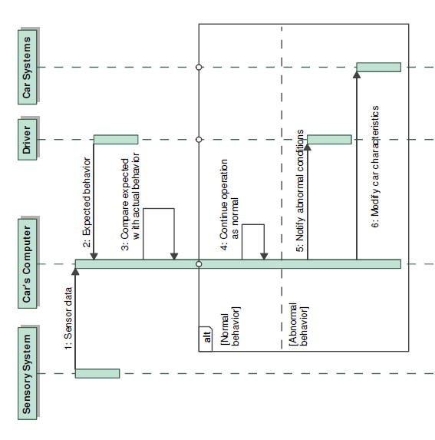
Figure 9: Sequence diagram for detecting abnormal conditions, and modifying car characteristics
Note: Due to being extremely simple and linear, Use Case 1, installation, has not been given its own sequence diagram.

Requirements Engineering
When determining the requirements of the Smart tire system, the overall functions of the system were considered. Constraints, parameters, and other necessary functions were realized as the development of the system requirements continued. Using a level of hierarchy system, high level requirements were determined which led to detailed functional and non-functional requirements. Although we do not have a complete list of specifications and attributes for our requirements, a very good sense of what the system requires can be obtained.
Table 1 shows the high level system requirements that the Smart tire system is based on.
R1 The system must provide data to the vehicle about the vehicle’s road-tire conditions.
R2 The system must suggest or implement adjustments to the vehicle to assist the driver.
R3 The system must not require major modifications to the vehicle.
Table 1: Initial Requirements
From Table 1, the main functions of the system can further be broken down into functions that the system requires. Table 2 tabulates those required functions.
Index | Structure | Behavior
1.1 | Sensor node reliability | The total sensor node has to be99.9% reliable.
1.2 | Sensor node lifetime | The lifetime of the sensor node is desired to be as long as the lifetime of the tires.
1.3 | Control box reliability | The control box needs to as reliable as possible.
1.4 | Control box network control | The network control has to synchronize up to 12 signals at once.
1.5 | Control box calculations | The control box needs to be able to perform all the calculations necessary.
1.6 | Control box error | The error of the control box needs to be within 5%.
2.1 | Control box vehicle adjustments | The control box needs to be able to make or suggest vehicle adjustments as necessary.
3.1 | Sensor node weights | Total weight of sensor node should be less than .5 oz.
3.2 | Sensor node power use | Total power used by sensor node should be less than 10 mW.
3.3 | Sensor node size limit | Total size of sensor node should be less than 1 cm^3.
3.4 | Sensor node vibration limits | Sensor node must be able to withstand a certain amount of vibration.
3.5 | Sensor node temperature range | Sensor node has to be able to withstand temperatures from -40 to 100 °C.
3.6 | Sensor node robustness | Sensor node needs to withstand 100 lbs of force.
3.7 | Sensor node power generation | Sensor node must produce a constant 10 mW when the vehicle travels at more than 5 mph.
3.8 | Sensor node signal strength | Sensor node must transmit a signal at minimum signal intensity.
Table 2: Detailed Requirements (Functional and Non-Functional)
The requirements in Table 2 demonstrate the functions required from the Smart tire system. Notably, the physical constraints of the sensor nodes, the energy scavenging and generating necessity, and the signal transmission strength appear to be the toughest obstacles to overcome. To determine whether these obstacles can be overcome, breaking down the system into components and subsystems, and seeing if these individual components and subsystems can meet the requirements of the system collectively, you would be able to get a sense if the task is accomplishable done or not.
Table 3 shows the component and subsystem requirements.
Requirement | Structure | Behavior
4 | Sensor Node | The system needs to have a subsystem: sensor node.
4.1 | Sensor node accelerometer | Accelerometers must be triaxial.
4.2 | Sensor node energy scavenger | Energy Scavenger must produce a constant 10 mW when the vehicle travels at more than 5 mph.
4.3 | Sensor node microcontroller | Microcontroller must have a power sensing function built in for safe start-up and shutdown.
4.4 | Sensor node A/D converter | A/D Converter must amplify, filter, correct offsets, compensate for resonance, sample greater than 10 kHz, and use 11-16 Bits.
4.5 | Sensor node microprocessor | Microprocessor must perform DSP, data compression, manage all activity including diagnostics, and have the required speed.
4.6 | Sensor node radio subsystem | Radio Subsystem must use a PPM modulator, Impulse-based UWB, it must transmit a triangular sinusoidal pulse shape signal, and it needs to supply minimum signal strength.
5 | Control Box | The system needs to have a subsystem: control box.
5.1 | Control box processor | This processor must perform DSP and have the required speed.
5.2 | Control box receiver | Receiver must be energy-detection-based.
5.3 | Control box A/D converter | Must convert the acquired signal.
5.4 | Control box controller | Must control and manage commands in the control box
Table 3: Component and Subsystem Requirements
You can see from the table above that the sensor node is split up into six components and subsystems, and that the control box is split up into four. The components and subsystems were chosen arbitrarily; so that the minimum number of components and subsystems would perform all of the functions necessary. Details of the requirements (all requirements) are shown in Table 4.
Requirement | Requirement Details and/or Specifications
1.1 | ≥ 99.9% reliable
1.2 | as long as the lifetime of the tires
1.3 | ≥ 99.9% reliable
1.4 | synchronize up to 12 signals at once, and use ISTD-MAC protocol
1.5 | must be able to calculate lateral and longitudal forces, load, load distribution, load transfer, kinetic friction, potential friction, tire material strain, tire pressure, temperature, single tire load behavior, slip, tire wear, and aquaplaning
1.6 | ≤ 5%
1.7 | must be triaxial
1.8 | must perform DSP and have the required speed
2.1 | must be able to make or suggest the following vehicle adjustments: brakes, engine torque, active suspension, improvement of longitudal dynamics, antilock braking system, and the traction control system
3.1 | ≤.5 oz
3.2 | ≤ 10 mW
3.3 | ≤ 1 cm^3
3.4 | TBD
3.5 | must withstand -40 to 100 °C
3.6 | must withstand 100 lbs of force
3.7 and 3.7.1 | produce ≥ 10 mW constantly when the vehicle travels at more than 5 mph
3.8 | TBD
3.9 | must have a power sensing function built in for safe start-up and shutdown.
3.10 | must amplify, filter, correct offsets, compensate for resonance, sample greater than 10 kHz, and use 11-16 Bits
3.11 | DSP, data compression, diagnostics, and have the required speed
3.12 | must use a PPM modulator, Impulse-based UWB, transmit a triangular sinusoidal pulse shape signal, and it must supply a minimum signal strength
3.13 | must be energy-detection-based and detect minimum signal strength
3.14 | TBD
3.15 | TBD
Table 4: Requirement Details and Specifications
The details of the requirements were provided in the article: “The Tire as an Intelligent Sensor.” Most of the requirements are well defined, but some require additional experimentation. The group from University of California Berkeley has been experimenting with this type of system, and what they found was experimentally was proven to be effective. We incorporated their results into our requirements.
Formulating the requirements of the system led to the following requirement diagrams. They correlate the sensor node with its requirements (split up into physical, performance, and component and subsystem requirements) and the control box with its requirements (performance, and component and subsystems requirements).
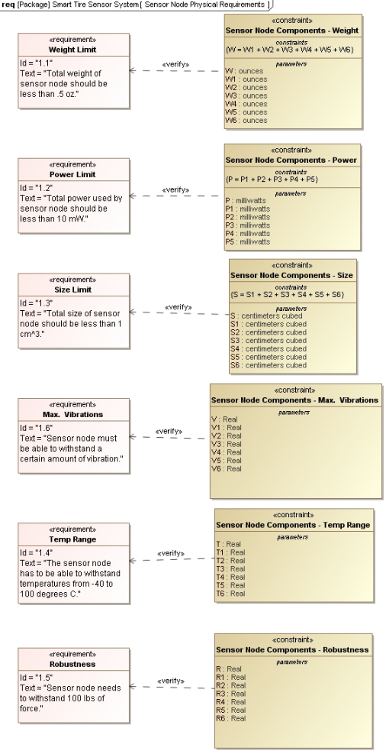
Sensor node physical requirements
Figure 10: Sensor Note Physical Requirements
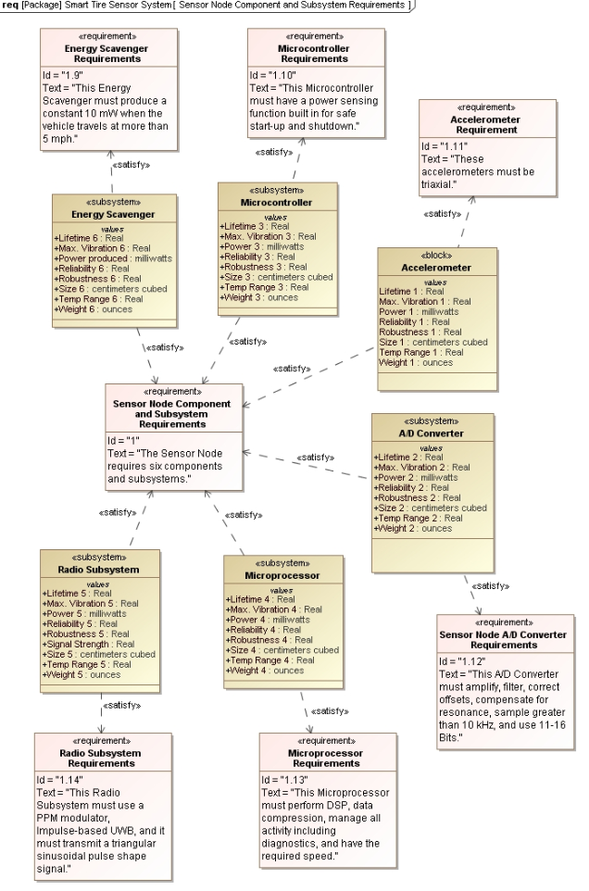
Sensor node component and subsystem requirements

Figure 11: Sensor Node Component and Subsystem Requirements
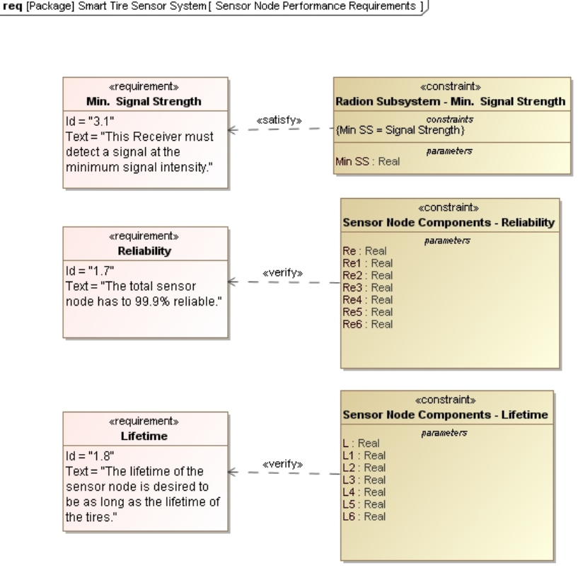
Sensor node performance requirements
Figure 12: Sensor Node Performance Requirements

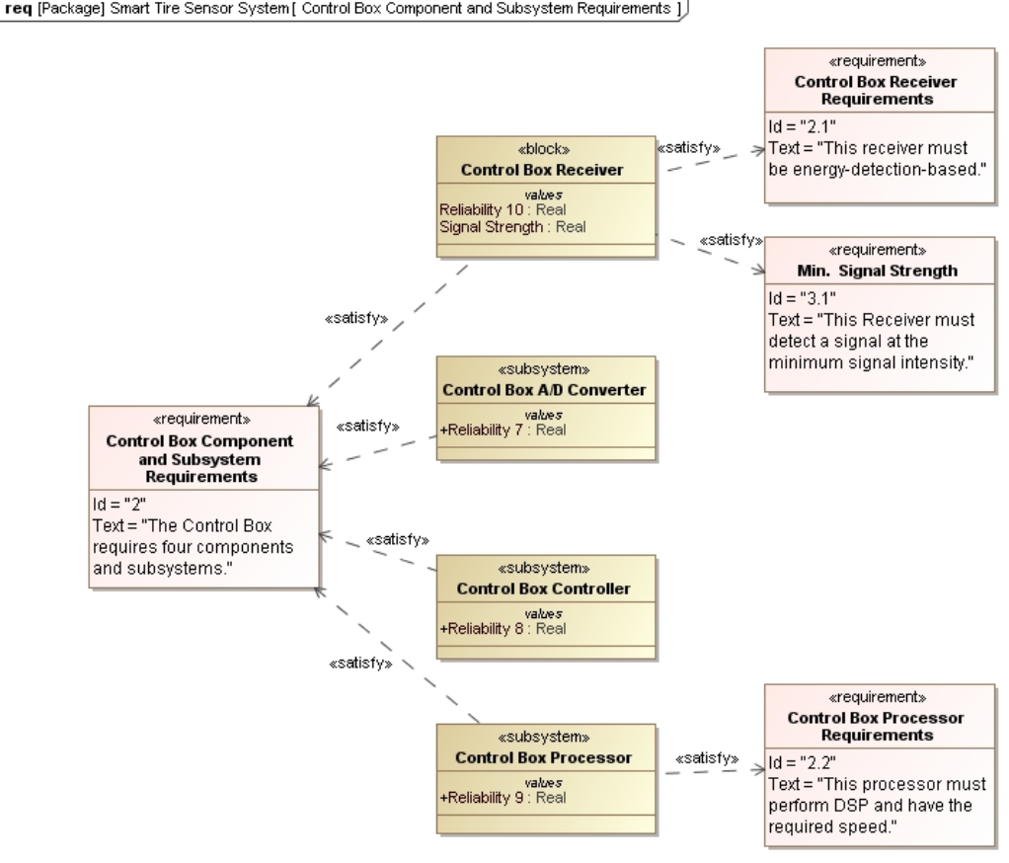
Control box component and subsystem requirements
Figure 13: Control Box Component and Subsystem Requirements

Control box performance requirements

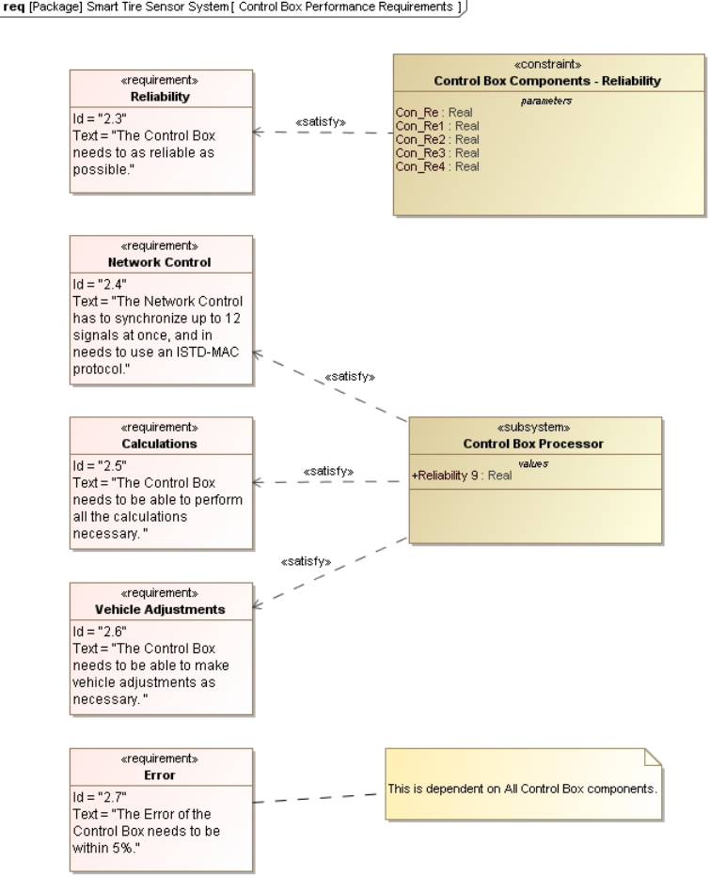

Figure 14: Control Box Performance Requirements

Traceability
In addition to the requirement diagrams, traceability was also performed. The traceability table that is shown in the following shows how use cases were met by the requirements developed.
Use Case | Scenario | Requirement | Description
Installation | Scenario 1 | R3 | The system must not require major modifications to the vehicle.
 |  | 4 | The sensor node must be pre-installed in the tire.
 |  | 4.2 | The energy scavenger might need an additional installation step.
 |  | 5 | The control box has to be implemented when installed.
Read conditions of roads | Scenario 2 | R1 | The system must provide data to the vehicle about the vehicle’s road-tire conditions.
 |  | 1.4 | The control box has to control the network.
 |  | 4, 4.1, 4.2, 4.3, 4.4, 4.5, 4.6 | The sensor node obtains and transmits the signal.
 |  | 5, 5.1, 5.2, 5.3, 5.4 | The control box receives and processes the signal.
Detect abnormal conditions | Scenario 3 | R2 | The system must suggest or implement adjustments to the vehicle to assist the driver.
 |  | 1.4 | The control box has to manage the various signals.
 |  | 1.5, 4.5 | The control box processor has to make the required calculations, determine abnormalities, and determine which vehicle adjustments to make or suggest.
 |  | 2.1 | The control box has to make or suggest vehicle adjustments.
Modify vehicle characteristics | Scenario 4 | 1.5, 4.5 | The control box processor has to which vehicle adjustments to make or suggest.
 |  | 2.1 | The control box has to suggest or make vehicle adjustments.
Table 5: Traceability of requirements to use cases

Systems-Level Design

System Structure
Figure 15 shows a hierarchal composition and association structure diagram of the smart tire system. Recognize that the sensor pack includes all the devices that will be in the tire. Also, shown are the weight, power and frequency constraints which set limits on the weight and power. Note that power sense pack is the inductive power unit which will be implemented to power the sensor pack.
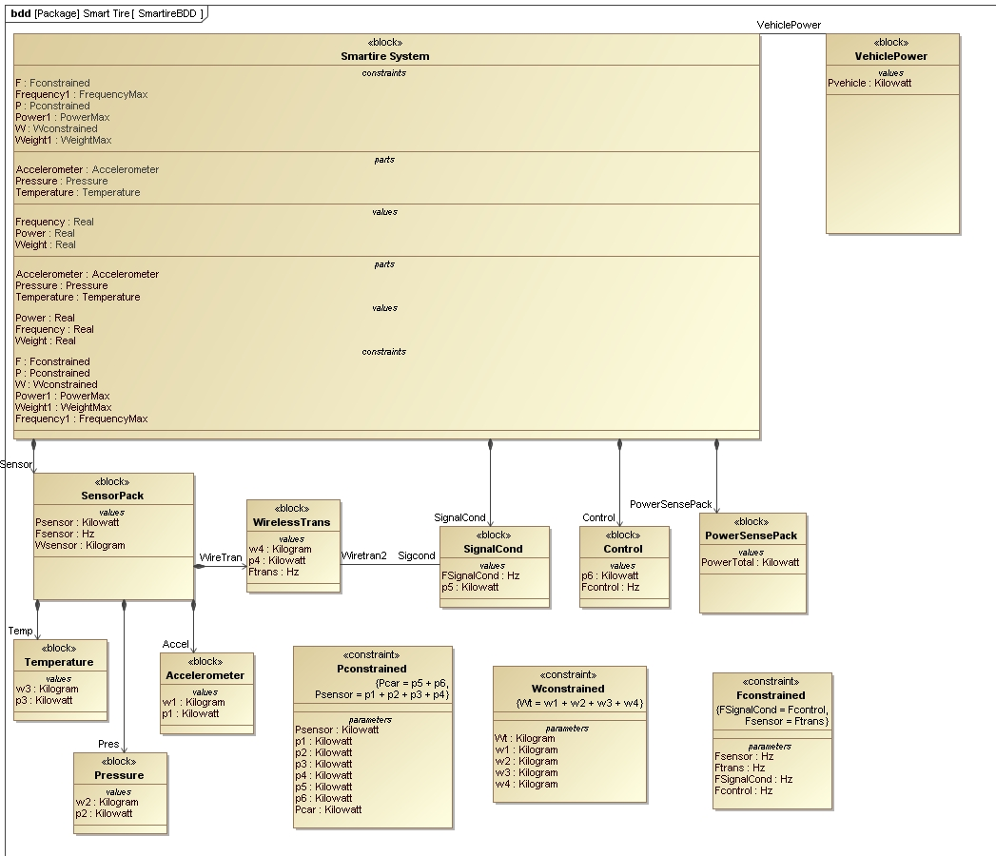
Figure 15: Smart Tire Structure Diagram

Tradeoff Analysis

Weight and Power
The weight and power of the smart tire system are easily analyzed because they are linear variables. The total weight of the sensor pack must be less than 15 grams. The weight and power constraints can be represented by Figure 16, a requirements diagram which defines the constraints so that varied sensors can be chosen and verified. Figure 17 is a parametric diagram which shows all the relations between the parts of the system and their respective constraints. Notice the frequency constraint is verifying that the output signals of the wireless transmitter and signal conditioning box do not include much error or attenuation in comparison to the input signals on the signal conditioning box and control ECU.
Figure 16: Power and Weight Requirement Diagram
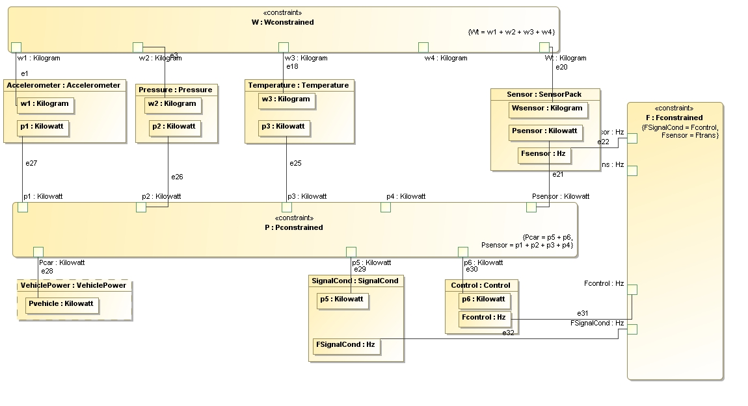
Figure 17: Parametric Diagram Smart tire system
Figure 18 depicts the verification parametric matrix for the power and weight. The output of this diagram responds with the percent positive or negative of the target value. The constant power use of each device allows for this simple relationship, limited only by the inductance power unit. However, by design these limits are well within reach because of the light weight of MEMS sensors and wireless transmitter. At largest they are only 1 cm² allowing the devices to be extremely light. Also, the power constraint is relatively low because the devices require little power around 1mW.
Figure 18: Verification Parametric Diagram

Inductive Power Unit
Figure 21 shows the inductive power unit which delivers voltage to the sensor pack where the voltage is directly proportional to the inductance of the coil. This is based on the number of turns, wire size and diameter. Each sensor requires about 1mW so 10mW is more than enough to power several sensors. Figure 19 shows the result of basic calculations which are made to analyze the trade-off between power and the unit’s number of turns.

Figure 19: Voltage Versus # of Turns

Performance and Accuracy versus Cost
To increase the performance and accuracy of the system more sensors must be added directly multiplying the amount of data to be analyzed which reduces error. The cost increases with performance because more sensors are required; however this cost is small in comparison to the cost of the tire manufacturing. Figure 20 shows the graphs showing the performance and accuracy versus the number of sensors and cost.

Figure 20: Performance and Accuracy versus the number of sensors
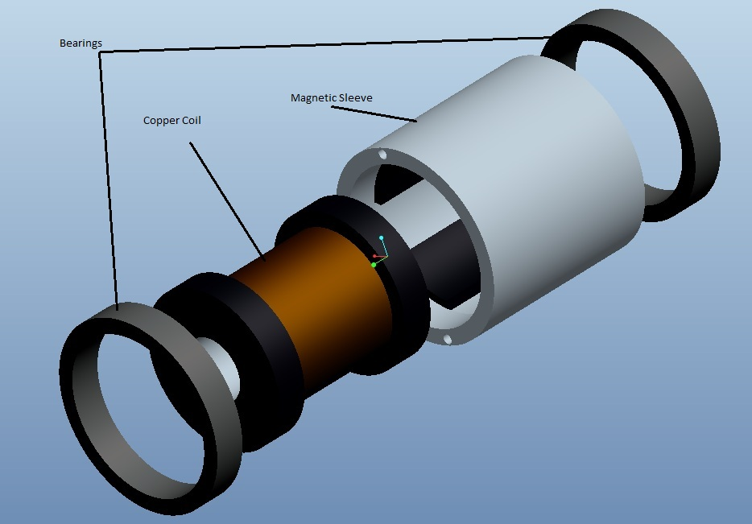
Figure 21: Inductive Power Unit Exploded View

Summary and Conclusions
Preliminary work on the Smart tire system shows that the system is quite complicated. Its complexity arises from the unique constraints that the subsystems are exposed to, but in addition, it’s quite complicated because of its diverse architecture. Smart tire sensors utilize components that draw on expertise from the mechanical, electrical, communications, software design, and signal processing fields. For improvement of the system, further research and design is necessary.
Resolving the problem statement into use cases, textual scenarios, requirements, and system architecture really helps visualize the system. It also assists in understanding what is required from the system. Through our design process, we were able to determine that the system must:
- generate power at the tire
- make accelerometer measurements of the road-tire conditions at the tire
- transmit the measurements to an on-board control box
- filter and process the signals
- make calculations based on the data gathered
- and determine what actions to take if necessary
The whole process must occur constantly and within hundredths of a second. The components and subsystems required to accomplish this was determined to be extremely constrained, and there is limited technology that can satisfy our requirements.
The system requirements that we developed were mostly well defined, by a group of researchers at the University of California Berkeley. Their prior research, described in their published article “The Tire as an Intelligent Sensor,” provided us with much insight into the functions and performances that have been experimentally proven to be successful for these types of systems. We were able to use a lot of this information in describing our requirements and constraints. Some requirements have not yet been determined however.
One aspect of the system design that we have shown that can be likely implementable in future designs is that of the energy scavenger. Our design in figure 21 shows an inductive powering unit that utilizes the wheel’s motion to capture and store energy in a capacitor system, that can later be released and create a constant power supply. This component is outside of the overall sensor node boundary, so further design and considerations are needed.
As with all the other parts of the system, the energy scavenging is still in its primitive stage. The goal however is to get this system to be fully operational so that the benefits it brings can begin to be realized. The results of a Smart tire system are reduction in accidents, improved car handling, better indicators of part statuses and warnings, and future implications such as being an assistant to accident-free driving. Smart tire systems can also be used in other systems such as planes and trains. Before implementation of the Smart tire system can occur, a fully operational prototype is necessary so that testing and a proper tradeoff analysis can be done.

References

Ergen, S., Sangiovanni-Vincentelli, A., Sun, X., Tebano, R., Alalusi, S., Audisio, G., Sabatini, M. “The Tire as an Intelligent Sensor”. IEEE Transactions on computer-aided design of integrated circuits and systems. Volume 28, July 2009. <http://ieeexplore.ieee.org/stamp/stamp.jsp?tp=&arnumber=5075807&tag=1>
Austin, Mark., Baras, John. Lecture Notes for ENES 489P Special Topics in Engineering: Hands-On
Systems Engineering Projects, January 2011

Sign-off Page

David Billet | - Abstract | ___________________________
 | - Problem Statement
 | - Textual Scenarios
 | - Simplified Models of System Behavior
- Summary and Conclusions
- References
Zach Panneton | - Systems-Level Design | ___________________________
 | - Tradeoff Analysis
Jason Saeedi | - Requirements engineering  - Summary and Conclusions | ___________________________

